Numeracy- This week we are looking at patterns and relationships. The first half of the tasks are revision and the second half is new tasks.
Online Task
Here are some games to play this week:
- Pattern Game (Try to increase the difficulty each time)
- shape patterns
Log on to Education City for more games linked to money through glow.
You can also use sum-dog at any point with regular challenges being placed.
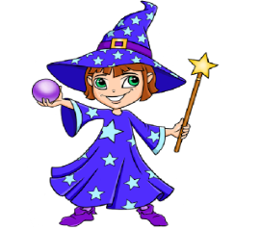
Written tasks
Wizard Challenge!
How many sums can you create to make the answer of 36. Using addition, subtraction, multiplication and division .

Chilly Challenge

2x4= 13x3= 26x4=
18÷2= 44÷4= 15x6=
Revision
Complete the following table by identifying the place and value of the underlined digit.
Place value Revision
Number | Place | Value
Eg. 2821 | Units | 1
4482
3732
1811
3890
9182
8221
2920
3652
7321

Sequence and Relationships
Complete the following colour patterns

Work out what each robot is doing to the first numbers (what have they added or subtracted)
7
2
14
6

92
71
19
12

103
82
52
63

Work out what is being done in each of the number sequences.
1, 3, 5, 7, 9, 11 | +2
2, 6, 10, 14, 18, 22
89, 85, 81, 77, 73,
1, 2, 4, 8, 16, 32
22, 30, 38, 46, 54, 62
101, 99, 97, 95, 93, 91
22, 33, 44, 55, 66, 77, 88
1, 3, 9, 27, 81.

Finish the following number sequences
- 2, 6, 10, _____, ______, _____
- 24, 21, 18, _____, ____, ____
- 89, 91, 93, ______, ____, _____
- 101, 106, 111, _____, ______, ______
- 292, 289, 286, _____, ______, _______
- 191, 201, 211, _____, ______, _______
- 1, 101, 201, ______, ______, _______
- 798, 788, 778, _____, _____, ________
- 282, 332, 382, _____, ______, ______
- 982, 881, 780, _____, _____, ______

