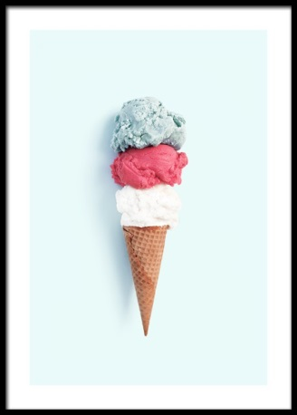
Writing- Recount - Title : The Best Holiday ….Ever !

A recount has three main parts a beginning, middle and end. Remember to describe the events in sequence, use linking words- first, then, next, finally.

Reading
- Log onto the Scholastic website using the log in details emailed to you from Mrs Rigg.
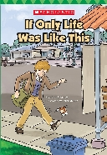
Reading Book

Reading- Read chapter 5, 6 and 7 this week.
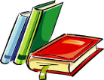
Literacy Here are some suggested activities. Choose one a day and do more if you wish.

Imagine the author is writing a new story involving some of the characters in your book.  Think of a title for this new book and draw a front cover. | Make a list of any words you are unsure of, look them up in a dictionary or online once you have had a sensible guess. | Make up three good questions you could ask someone about this book to test that they have read it carefully. Write down the answers you would expect them to give. | Read your book to a family member and try and read with expression to make it come alive for them.
Read chapter 6 of your book with a family member and ask them to predict what will happen next. Read on together to find out if they are correct. | Draw a large picture of one of the settings used in chapter 6. Label everything in your picture. | Copy your favourite sentence from chapter 5 in bold, colourful letters. Say why you chose it underneath. | Make a table or tally of all the adjectives (describing words) in chapter 6.
MTV (Making Thinking Visible)  Headline - Can you think of a title for chapter 5 What else could be the name for the chapter? Write why you chose the headline. | Write a beginning, middle and end style summary of chapter 6 and illustrate. | Read your book with a family member and ask them some questions about the text. | Draw a picture of your favourite part of chapter 7. Write a few sentences or more about why this was your favourite part.

MTV (Making Thinking Visible)
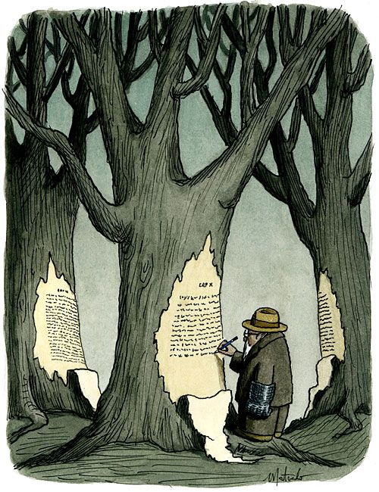

Take your time to look at the picture above -
1. What do you see in the picture above?
2. What do you think is happening in the picture?
3. What are some questions you would like to ask (What do you wonder?)

Challenge Questions
• What is the man writing?
• Why is he writing on a tree?
• What does he have on his hand?

