Monday 8th June 2020
These are suggested activities for Primary 2. Feel free to do them in any order you wish.

Literacy
This week’s phoneme is: kn (know)
Common words : under, know, were, thing.

Can you find things in your house or garden that have this kn phoneme sound? I have found something in my house : knife

Literacy Assignment
Is it a question?

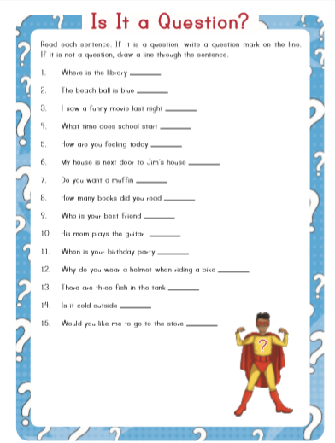

Maths Assignment
Say 2, 5 and 10 times tables out loud.
Count in 2’s, 5’s and 10’s up to 50 or beyond if you can.
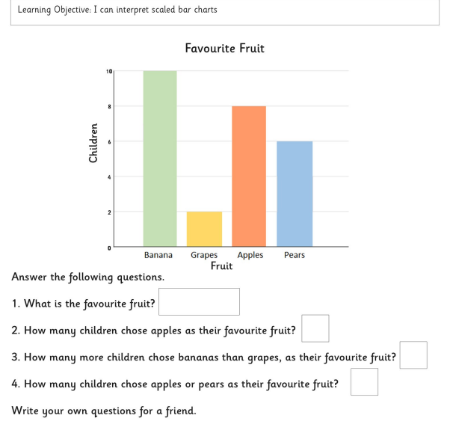

Fun Activity
The sun moves throughout the day. Try and map where the sun is at different points of the day so when you wake up, at lunchtime, before you have dinner and when you go to bed. Does it change each day? Draw a picture of your home (putting your home in the middle of the page), add north, south, east and west arrows on it then add where the sun is and the time you have checked it throughout the day. What other ways are there to measure the sun’s movement?

Can you write a set of instructions to help us keep our hands clean when we return to school? Remember words like then, after that, finally, next.
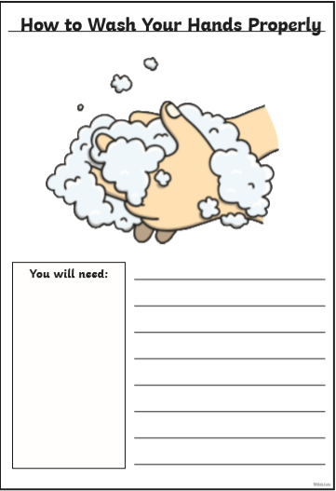

Maths
Say 2, 5 and 10 times tables out loud.
Count in 2’s, 5’s and 10’s up to 50 or beyond.

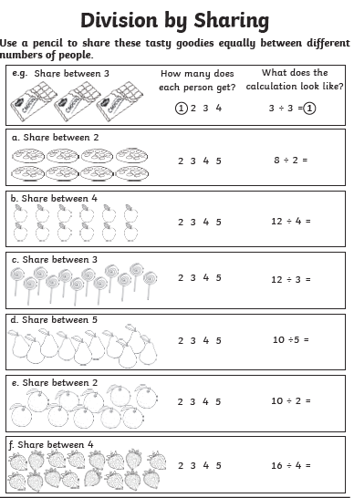

Activity
We all need to eat a balanced diet, even animals. Pick a pet of your choice and investigate what food it should and shouldn’t have to keep it happy and healthy. Make sure you include the amount it should have of each type of food. Draw a picture of its food bowls if you prefer.

Proper Nouns
Proper nouns are the names of people and places.

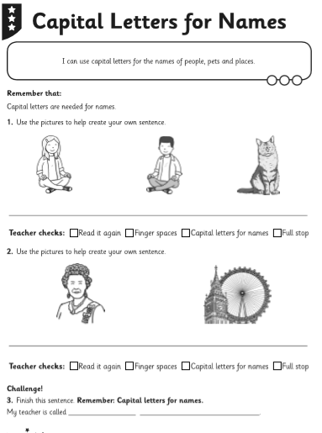

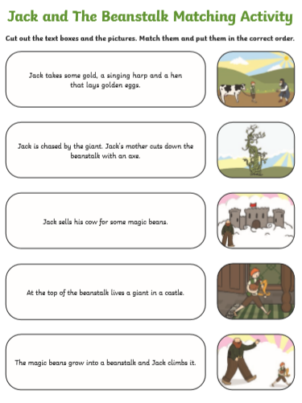
Spanish
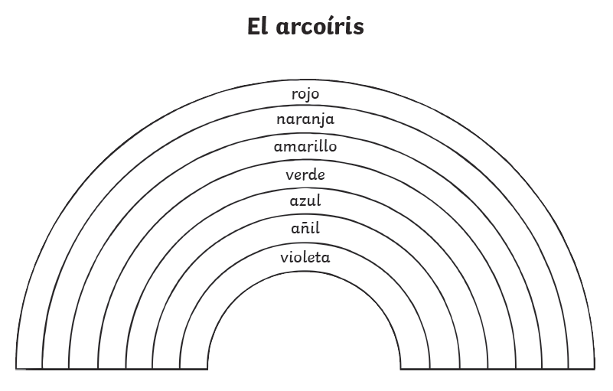
NLC Maths and Numeracy Learning at Home First Level: Number and Number Processes

Use the number lines to help you work out these addition and subtraction questions.
11 + 2 =
16 – 4 =
2 + 9 =
20 – 6 =
13 + 3 =
18 – 7 =
17 + 3 =
15 – 8=
3 + 12=
20 – 12 =
1 + 13 =
15 – 9 =

Fun Activity

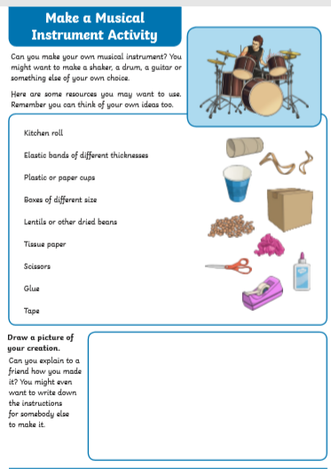

Maths
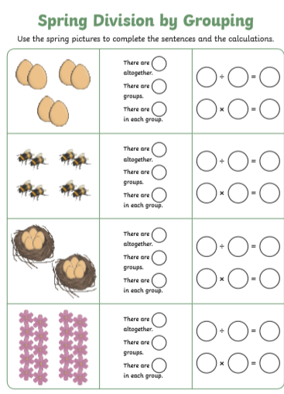

NLC Maths and Numeracy Learning at Home
First Level: Patterns and Relationships
Number Sequences
Number patterns and sequences can use addition, subtraction, multiplication and division.

Can you complete these number sequences? What is the rule for each number sequence?
15, 20, 25, 30 ____ _____ _____
100, 90, 80, _____ _____ _____
22, 24, 26, 28, 30, _____ ______

Using the rule and the starting number, write out the first 6 numbers in each number sequence.
Rule | Start | First 6 Numbers
Add 5 | 11
Subtract 3 | 27
Add 20 | 15
Add 6 | 13
Multiply by 2 | 9
Subtract 4 | 29

Comprehension
Listen to the song “You’ve got a friend in me” from Toy Story.
https://www.youtube.com/watch?v=CNi02gxTI1M
You got a Friend in Me
You've got a friend in me You've got a friend in me When the road looks rough ahead And you're miles and miles From your nice warm bed Just remember what your old pal said Boy, you've got a friend in me

You've got a friend in me You've got a friend in me You've got a friend in me You've got troubles, well I've got 'em too There isn't anything I wouldn't do for you We stick together and we see it through You've got a friend in me You've got a friend in me

Some other folks might be A little bit smarter than I am Bigger and stronger too Maybe But none of them will ever love you the way I do It's me and you boy

And as the years go by Our friendship will never die You're gonna see It's our destiny You've got a friend in me You've got a friend in me You've got a friend in me

Questions
- Listen to and read the first verse. What do you think the song is about?
- Read the line “It's our destiny” what do you think destiny means?
- The author says “You've got troubles, well I've got 'em too” but what is the message the author is trying to tell us?
- Can you think of a new title for the song?

Literacy Check up day!!!!!!
Spell check and Phoneme check

Get someone in your house to check if you can spell these words.
- know
- knee
- under
- knot
- were
- knuckle
- thing
- knit
Well how did you do?

Maths
Maths Check
- 16+9=
- 26-6=
- 5+13=
- Double 15
- Double 11
- 16+7=
- 26-12=
- 71= __ tens and __ units
- 32= __ tens and __ units

- 75, 70, __, 60, 55, __, 45
- __, 80, 70, __, 50, 40, __
- 10 more than 13 =_____
- 10 more than 60 =_____
- 10 more than 77= _____
- 10 less than 66 = _____
- 10 less than 43 = ____
- 2x10=
- 5x9=
- 5x ___=25
- 2x ___=16
- ___ x2=14
- ___ x4=18

How did you do???

