St Andrew’s High School
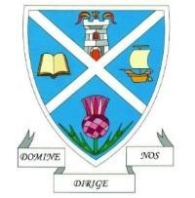
SCIENCE
DEPARTMENT

P7 Transition Booklet
DO Try This at Home!

Dear P7s
Introducing … Science at St Andrew’s High School!
Under normal circumstances, we would be looking forward to showing you around our Science department this month and letting you do some experiments.
Because that is not possible this year, we have decided to bring the Science to you at home.
The next few pages take you through some experiments that you can try in the house, using everyday substances you can easily buy from a supermarket, or in many cases you might already have. Check the shopping list on the next page.
Try some of these activities and try to think about the questions on each one, then read about the science behind each activity.
Some of you might like to take photographs of each stage of the experiments or even create short iMovies with cool sound tracks that you can share with us when we eventually meet.
Good luck and enjoy. We are looking forward to meeting you all.

St Andrew’s Science Department
xperi

Shopping List

Vegetable oil

Fizzy tablets

(
eg Berocca or own
brand)

Food colouring

String

Kitchen towel

Felt tip pens

Cornflour

Lemon

Lime

Bicarbonate of soda

(
baking soda
)

Eggs

Experiment 5: Lemon/Lime Volcano 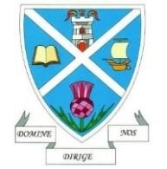
This experiment shows a chemical reaction that can happen between the acids in fruit juices and bicarbonate of soda. It will work with any citrus fruit.
What you Need:
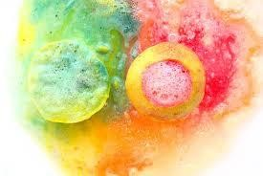
Lemon

Lime
knife
Fork
Food colouring
Bicarbonate of Soda (baking soda)
What to Do:
- Cut the two ends off a lemon or lime. Place the fruit on one of its flat edges on a plate from your kitchen.
- Using the fork, squash up the fruit to partly hollow it out, this will release some of the juice.
- Add a few drops of food colouring into the top of the fruit.
- Add a large spoonful of bicarbonate of soda to the top of the fruit, then use the fork to mix it a little with the juice.
- Watch what happens!

Questions to Think About:
- What happened when the bicarbonate of soda came into contact with the fruit juice?
- Was there any difference between the lemon and the lime?
- What other fruits could you use? Do they react differently?

What’s the Science?
Fruit juices contain CITRIC ACID which when mixed with bicarbonate of soda reacts to form CARBON DIOXIDE and SODIUM CITRATE. The release of the carbon dioxide is what causes the fizzing and bubbling.

