World War II – Propaganda

Watch this short video about propaganda during World War II and answer the following questions. Try to answer in sentences like we do in class.
https://www.bbc.co.uk/teach/class-clips-video/history-ks2-how-propaganda-was-used-during-world-war-two/zr77wty
- What is the meaning of the word ‘propaganda?’
- What was crucial to Britain’s success during World War II?
- What was the role of ‘The Ministry of Information?’
- Why was propaganda used during the war?
- What role did propaganda play in ‘The Miracle of Dunkirk?’
- One propaganda campaign was titled ‘Careless Talk Costs Lives’ (see posters below). What do you think The Ministry of Information were trying to achieve through this message? You may need to conduct your own research to find out.
- Give an example of when propaganda has been used for negative purposes.
- In the present day, governments use ‘spin’ to spread a positive message about the job they are doing. Do you think it is acceptable to put a positive spin on everything when there is no war effort in place? Explain your answer.
Posters for Q6 –
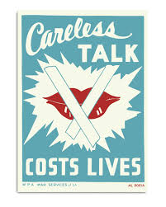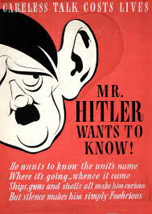

Answers
1.
2.
3.
4.
5.
6.
7.
8.

