ICT Home Learning Challenges

Programming – Hour of Code  Go to https://code.org/learn  and choose one of the activities to complete.  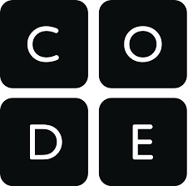 | Login to your Glow account  - Check your e-mail for an e-mail from your teacher.  - Use your e-mail to keep in touch with some friends or family members  - Check to see if you can login to Microsoft Teams | Go to the “Waffle” from your e-mail in Glow.  - Choose Forms  - Choose new quiz  - Make a quiz (choose a subject you know about)  - Share the quiz with your friends/teacher using the share button
Download scratch from here (it’s free)  https://scratch.mit.edu/download  or try some online scratch activities here  https://scratch.mit.edu/studios/414060/  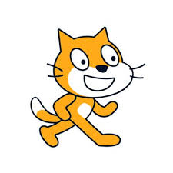 | Use scratch to create a crystal pattern.  - First draw a shape (think of the angle you need to turn) Use a repeat block (Think of how many sides it has.  - Then use a repeat block to turn the shape slightly. (Think of how many times you will need to turn round a full circle. HINT full circle = 360˚)  - Can you change the colour of the line you are drawing  - Download Mrs Rigg’s program to help with the coding if you are a bit stuck.  - Try it with different shapes – triangles, hexagons, octagons etc | Use Kahoot and take part in one of Mrs Rigg’s quizzes. Follow the link or download the app.  www.shorturl.at/chiMU  Use the following game PINS  Prefixes – 0565928  Relative Pronouns – 0324363  Spanish Food – 0136590  Spanish Drinks - 0764734

