How to Select Classes for the School App

- Once you have downloaded the school app, it will appear on you phone. Please open the app.

- The opening page of the app will look something like this.
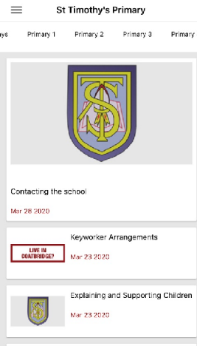

- To ensure you can see all of the information for your child, please click the top left icon (3 straight lines).

- This will give you a number of options. Please select Choose Categories.
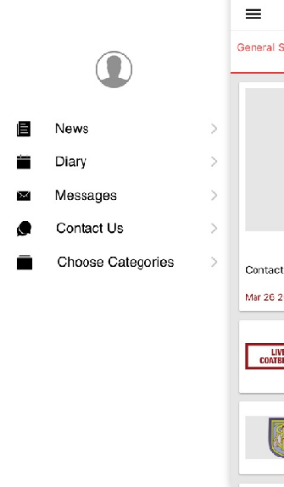

- Here you can select the Primary Stage for your child/children. If you have children at different stages, please select multiple stages.
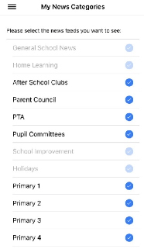

- The classes you have selected will appear in the top header and you can access them from here by scrolling along and selecting.

