30.3.20 P5 Daily Tasks

Active Literacy
7-Up Sentences 
Try and make these sentences more interesting using our 7 up strategy that we use in class. Remember at the end of it, you should have a paragraph NOT seven sentences.
- Add in words like adjectives to describe.
- Add in chunks of information to your sentence.
- Add on at the beginning of the sentence.
- Add on at the end of the sentence.
- Change some of the words within the sentence.
- Use alliteration for example - The slimy snake slithered away.
- Include a simile for example - As sharp as a tack.
- Change words within the sentence.

The little girl sat alone in The Workhouse.
The chimney sweep looked up the chimney.

Phoneme Task
Last week you should have already completed a Phoneme Chart with the different representations of ‘au’. You can now use our Diacritical Marking Code. Remember a single sound is one dot, a split phoneme is a bridge and a joined phoneme is a line.

Edit the Page
We all need a little practise to use capital letters, full stops and commas. Here is a paragraph that you can read to someone and see if you can ‘fix’ the mistakes.

Read the passage below aloud to yourself or to an adult. Can you read it without taking a breath? How many times did you have to stop and breathe?

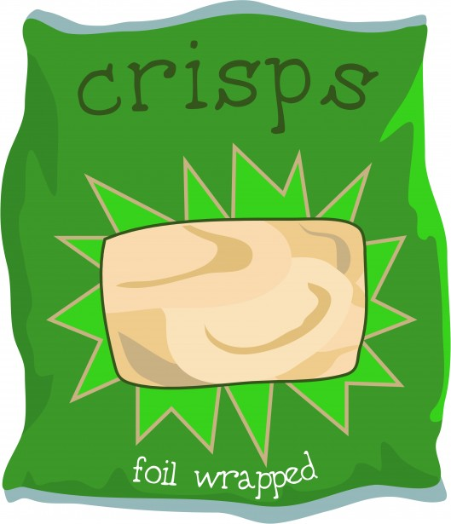
mum is trying to make me healthy packed lunches
now that my school has banned me from having crisps
and chocolate in our lunch boxes today she made me
chicken and salad sandwiches which i like so i was
pleased that is good she said she also included an
apple and banana a pot of yoghurt and a homemade
raisin flapjack sometimes i have a tub of pasta salad
instead of sandwiches my favourite is tuna and
sweetcorn i also like pitta bread with plenty of crunchy
salad i miss having crisps a bit but i know it is healthier
for me not to eat them too often

Now read it again, thinking about where the full stops (for a long pause) and the commas (for a short pause) should be. Can you add them in? Don’t forget to use capital letters after full stops!

Maths
Remember to keep practising the 2,3,4,5,6 and 7 times tables. Say them out loud or write them down using coloured pens or pencils. Challenge someone in your family to test you on them.

We have been working on telling the time in class – try converting the time to analogue, 24 hour clock and 12 hour clock.

Converting Time Worksheet

Time in words | 24-hour clock | 12-hour clock | Analogue
Seven o’clock in the evening | 19:00 | 7:00p.m. | 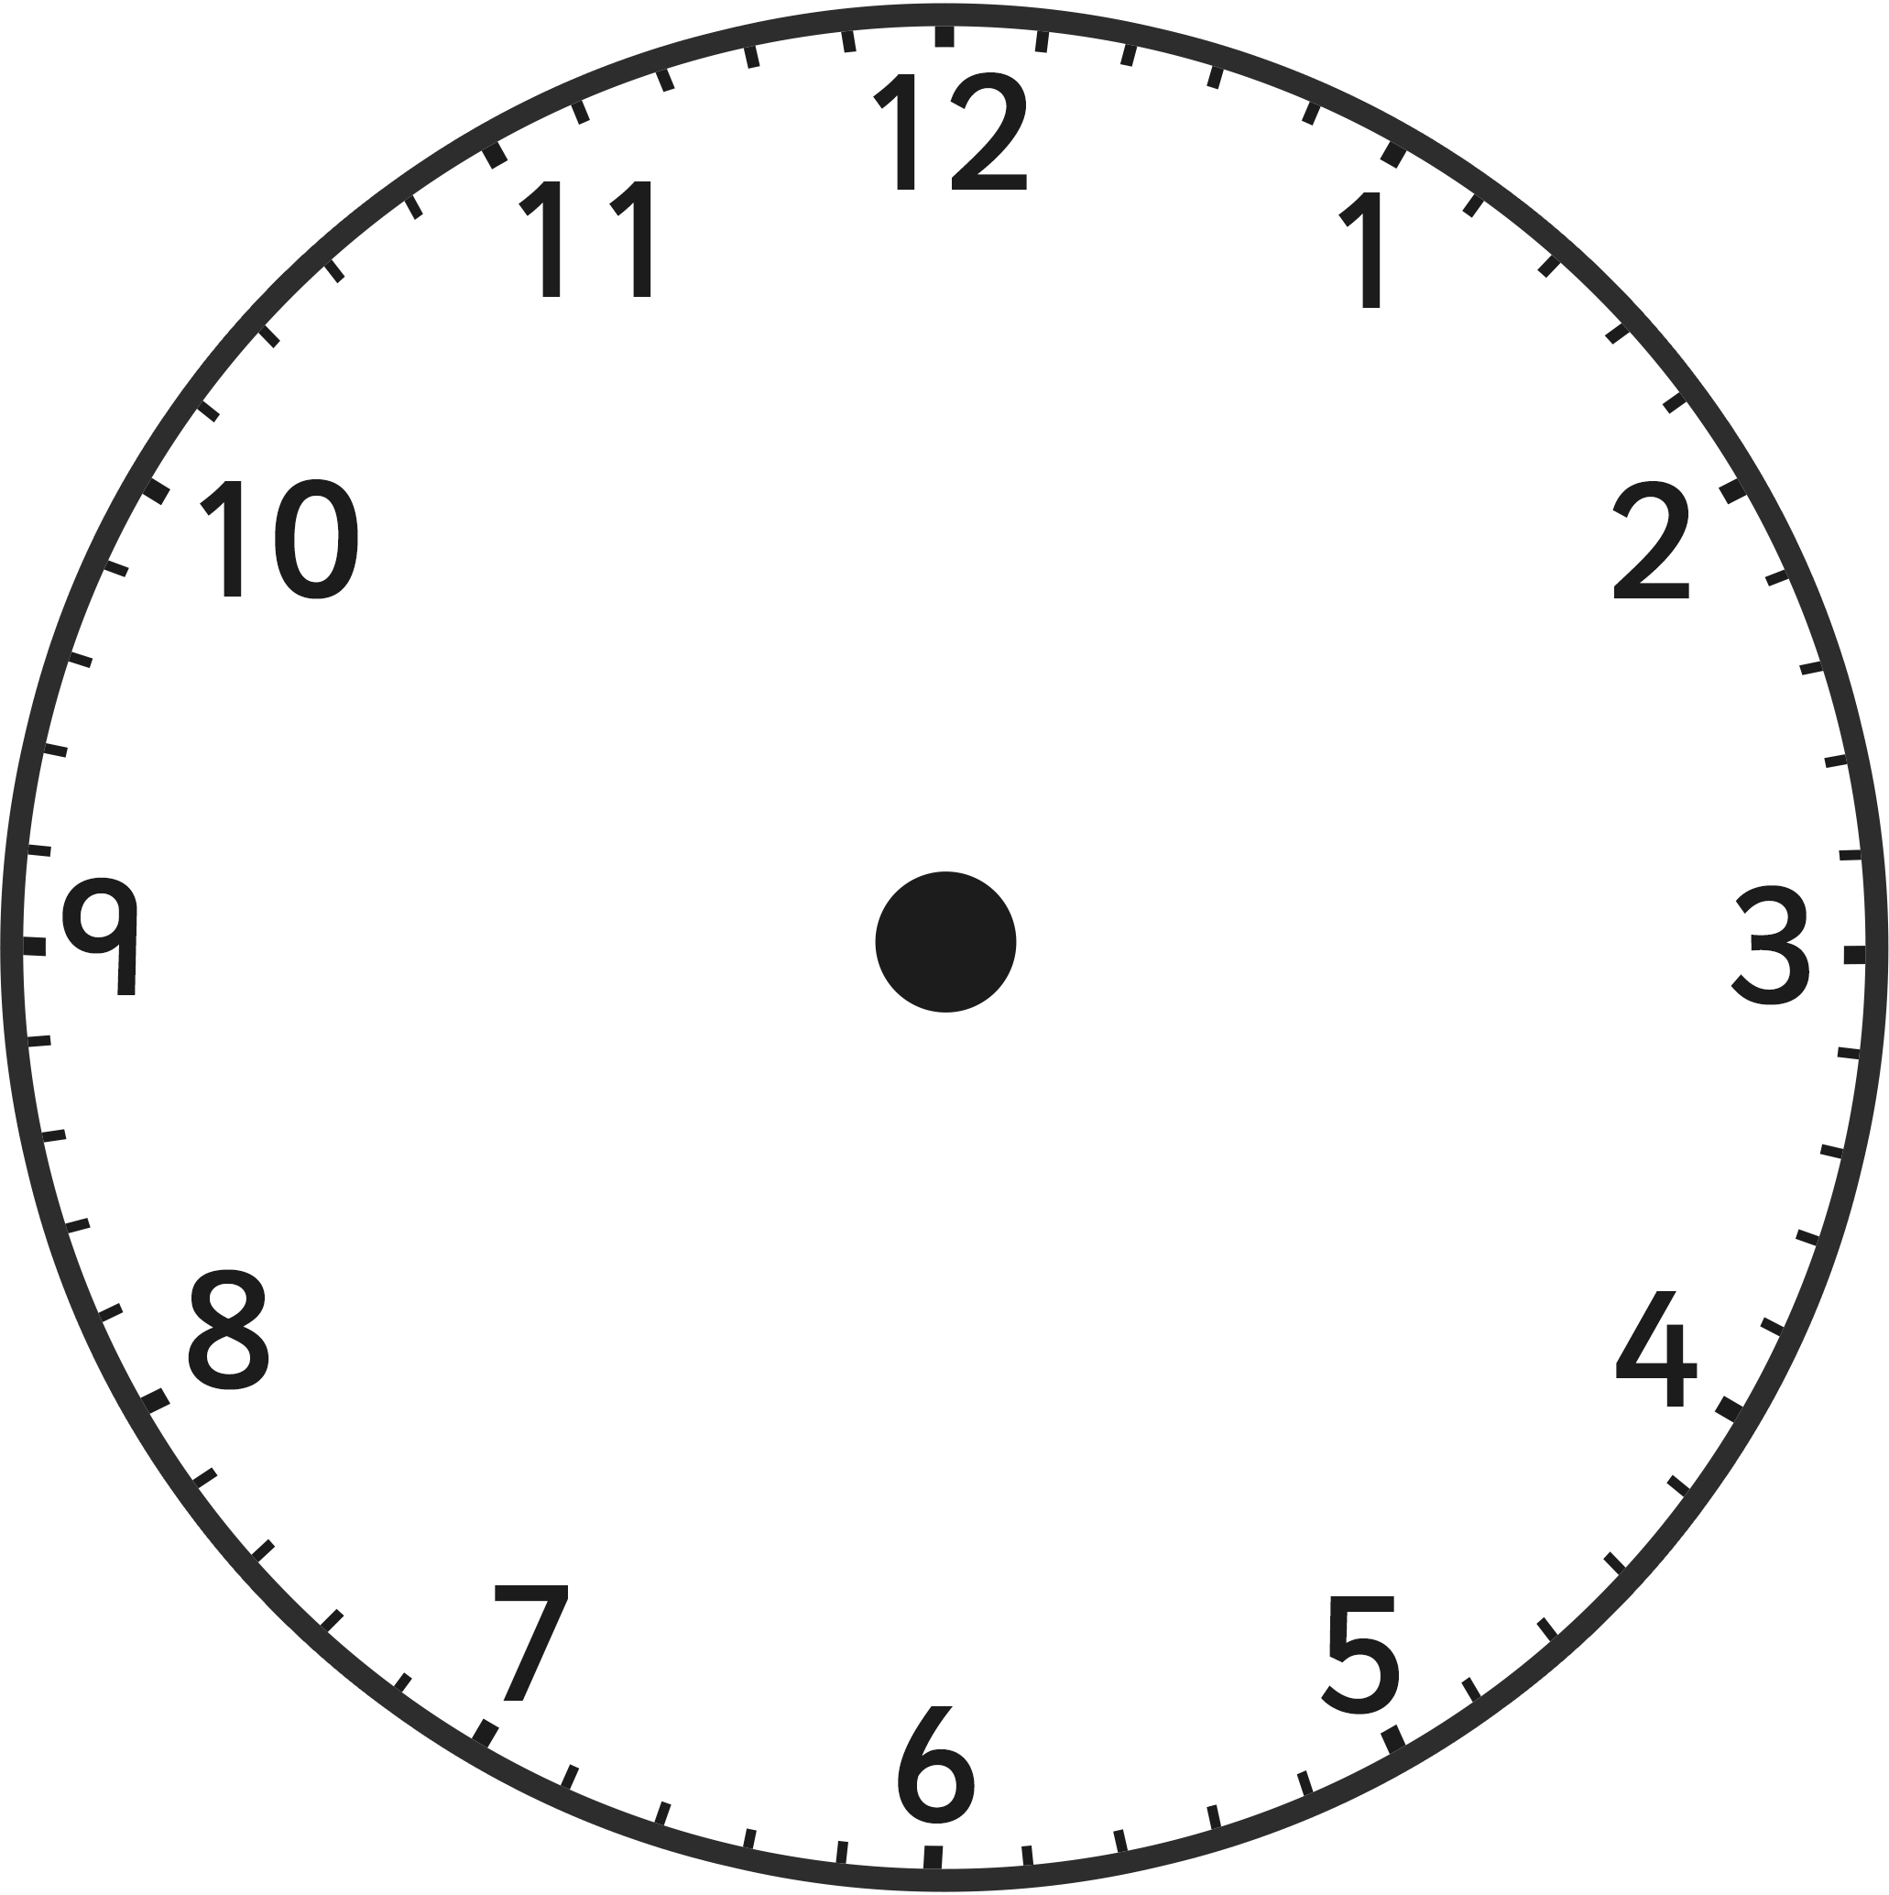
 |  | 11:00a.m.
 | 14:15
 |  | 8:20p.m.
midday
 |  | 6:40p.m.
midnight
Seven minutes to eight at night

Please remember to log into Topmarks.co.uk to complete the Daily Ten – practise adding, subtracting, rounding and multiplication – this will help you keep your skills up to date.
Don’t forget Sumdog too!

Topic 
Search for https://www.literacyshed.com/victoriandiaries.html and listen to the story of a Victorian child. Try to write a diary as though you were a Victorian child. You could possibly be a chimney sweep, maid or someone from the workhouse. We have had some practise with this in school. Remember to use the past and present tense and let your imagination run wild.

If you are looking for other topic related work to do – why don’t you have a go at researching what Victorian Schools were like in comparison to our modern day schools?

Children, try your best to complete some of these tasks, but the main thing is that you are safe and healthy. Read (as much as you can) books that you enjoy and enjoy spending time with your family. Remember when you log into Glow, go into Outlook to email Mrs Prunty or Mrs Simpson.

Parents – as we have said before, please do not feel under pressure to complete all of these tasks. Encourage the children to do as much as they can but if it becomes too stressful then just leave it. As long as you are all safe and well that is the main thing. No work will be posted for the next two weeks due to the Easter break. I think we all need a much needed rest. Please remember, we can be contacted via Glow and we will send out messages to the children to keep them up to date.
Take care, Mrs Prunty and Mrs Simpson

