Week Beginning 23.3.20 P5 Tasks

Maths – Revise 6 and 7 times tables – go onto Topmarks.co.uk and search for the Daily Ten. Complete multiplication challenge timing yourself. Challenge yourself by reducing the time it takes to complete. Other times tables we should also be revising are: 2, 3, 4, 5 and 6 times tables.
Multiplying Decimals by 10 and 100. Copy this chart into your homework jotter and complete.
Complete the chart to show that you can multiply a decimal by 10 or 100. Remember that the decimal point doesn’t move. Don’t forget 0 where it’s needed!
Decimal Number  100s 10s 1s . th hth | X by 10  100s 10s 1s . th hth | X by 100  1000s 100s 10s 1s . th hth
1. 6
2.4
0.2
0.9
12.4
17.8
1.02
5.9
23.6
4.3 0

Maths’ Number Talk
40x4= 120x60= 432x6=
Remember to use your strategies. Rounding, Place Value Knowledge, What you know already, Partitioning
Log onto Sumdog and find someone to challenge you. Good luck!

Are you up for this challenge? -
Layout these sums as chimney sums and give them a go!
26x12= 54x23= 38x14= 75x12= 84x26= 132x26= 258x32=

Word Problems

Crème Eggs come in boxes of 68, how many will there be in 8 boxes?

JD Sports are having a sale: North Face T- Shirts are reduced to £12.99 and Nike Air Force One Trainers are on sale for £75.99. John buys 3 T-Shirts and 2 pairs of trainers. How much did he spend in total? (Remember that you can use rounding to help you).
Now you’re the teacher! 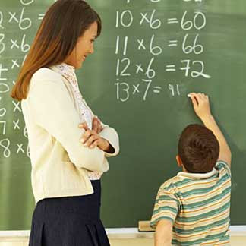
You try and make up your own multiplication word problems and get an adult to work them out and you check to see if they got it right!!!!!

Active Literacy
Create a phoneme chart with the different representations of au – au, aw, o and a. For example – pause, law, on, almost.

Topic Work The Victorians– Making Thinking Visible – See, think, wonder.
Look at the following picture – 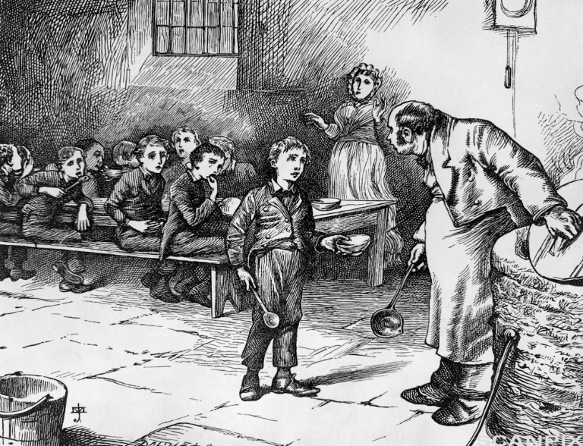
Create a grid as we do in class – you can use a picture of an eye for see, a brain for thinking and question mark for wonder.

What do you see when you look at this picture?
What do you think when you look at this picture?
What do you wonder when you look at this picture?

Parents, please do not feel under pressure to complete all of these tasks.
Mrs Rigg has put links to educational websites for further interactive learning.
Thank you, Mrs Simpson and Mrs Prunty Room 11 and Room 12.

