St Thomas’ Primary School App

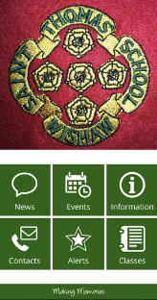

St Thomas’s Primary school is now running our school app.
The St Thomas Primary App provides quick and easy access to information and messages from school.
This is the most direct way for your school to provide you with rich, timely and relevant information. You can read it there and then, browse it later, respond if necessary, or simply use it as a reference source when out and about. All straight from your phone.
News
Blogs, website news, newsletters, Twitter and Facebook, video, pics of the pupils at work and play and key documents are all collected in one place on the app. They will be sent to you by push notification alert so you won’t miss them.
Events Calendar
Having the school calendar on your phone is a lot more accessible than the one pinned to the fridge and more accurate too as it’s automatically updated regularly. Use the Add To Calendar feature to add priority events for you to your personal calendar.
Alerts
Select yourself into whichever groups you most want to hear from to ensure you receive letters home, reminders, late bus announcements, forms, accounts of the day, newsletters and much more. You are in control so there’s no more being bombarded with everything or feeling left out of the loop.
Photos and Video
Pictures tell a thousand words and video a million. Watch them when the school sends them out, then again with relatives next time you see them.

How to get the app:
First things to do when downloading the app:
Playstore or Appstore
Once in Search for Scot Ed the Icon looks like this

Next Step search St Thomas, you only have to do this the first time.
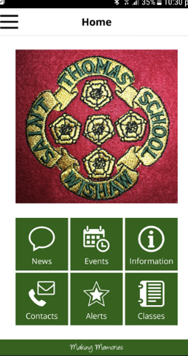
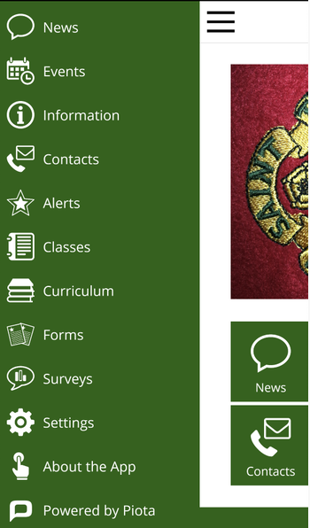

- Go to the Settings page where the three lines are in the top left hand corner and select channels before you opt yourself into the groups of interest to you. Leave "Urgent" alerts switched on: this is for important messages to the whole school.

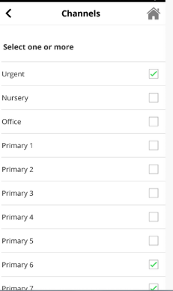
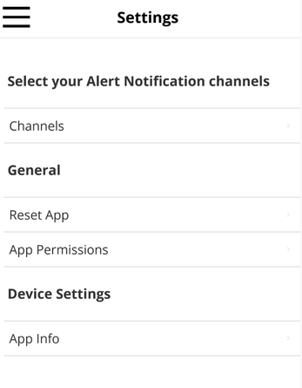
- Go to the Events section and add events of interest to your phone calendar as above if you would like reminders about them nearer the time.

- The app is designed to be a one stop shop for all quick information you need about school. If we have missed out something you would like to have seen please drop a quick message to us via the Send Feedback button on the About the App page.
From the Home screen:
Events section. You can view this in calendar page format or click the list view button at top right of screen to see it as a scrolling list. Events can be added to your phone calendar by clicking the "calendar plus" icon for an event.
Alerts section. This is a log of messages sent to you with push notifications. Go here to catch up on any missed messages since you last used the app.
More... section. This takes you to a secondary menu with additional sections including:
Settings section. This allows you to filter messages so you receive notifications relevant to your child(ren)'s life at school.
About the App section. Holds legal information about use of personal data, cookies etc and a feedback link if you would like to comment on the app.
Mr Finnon
Acting Principal Teacher

