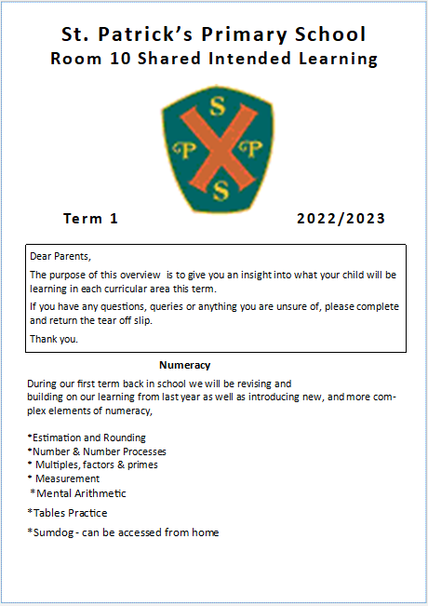

Literacy
Continuing to build on the work from Primary 5 using North Lanarkshire reading programme.
Reading - Four day reading programme that comprises: -
1. Fluency
2. Comprehension
3. Writing linked to reading novel
4. Talking and writing linked to reading/novel

The pupils will follow 6 comprehension strategies to develop their critical literacy skills.
The 6 strategies are:-
• Using Active Thinking about Prior knowledge
• Active Thinking about words and phrases
• Active Thinking about Sensory Images
• Using Active Thinking to Draw Inferences
• Using Active Thinking to Find Main Ideas
• Using Active Thinking to Summarise the Text
The whole class will be working on a joint novel to develop and enhance these skills during the start of the first term.

Phonics/Spelling
• Phonics and Spelling is combined. Children will be taught two types of spelling approaches.
• Problem Solving Phonics into Spelling approach.
• Thinking Strategies approach.
The Primary 6 Spelling structure works on a 5 weekly cycle focussing on:
• Week 1: Affixes
• Week 2: Homophones and Confusions between words
• Week 3: Common Words
• Week 4: Spelling Rules
• Week 5: Consolidation and Revision of previous weeks’ words

Taught Writing— poetry, reports, recounts, narrative

Religious Education—This is Our Faith
This term the children will enrol for the Pope Francis Faith Award and explore living their faith in the world.
This continues into P7 where they may achieve the award by living and reflecting upon the Gospel values in their lives.
They will learn and reflect upon the story of Lourdes and St Bernadette in relation to the
upcoming visit of St Bernadette’s relics to Carfin Grotto .
They will reflect upon the lives of the saints and how they can be an inspiration in their own lives and consider the importance of Advent in the church’s year.
They will be encouraged to actively live out their faith and will attend hymn practices and mass regularly.

Social Subjects
This term the children will be learning about:
• Cops and Robbers
• Hallowe’en and Bonfire Night
• Explorers
• Christmas

I.C.T
The children will continue to use the internet as an asset and aide to their learning where appropriate eg Sumdog and further engage in appropriate behaviour and safety while using the internet.
They will undertake a four week programme of coding with Mrs Whomes which they will be able to use in different ways.
They will use the internet to research their topic work and consider the importance of selecting relevant information and the reliability of the internet as a source of information.

Other Relevant Information
• P.E days— Thursday and Friday
• Mrs Brown will deliver Spanish and STEM once a week.
• Miss McGregor will deliver Kodaly music lessons once a fortnight.

.

