 | St. Patrick’s Health and Wellbeing Newsletter  Issue 1 |  | December 2021

well-being wednesday
Wellbeing Wednesday  Wellbeing Wednesday is something that the whole school does. It is when the classes go out to the Coby, park or a graveyard. Lots of people love it because they get fresh air and they feel free and amazing.  Primary 4 enjoyed toasting marshmallows |  | 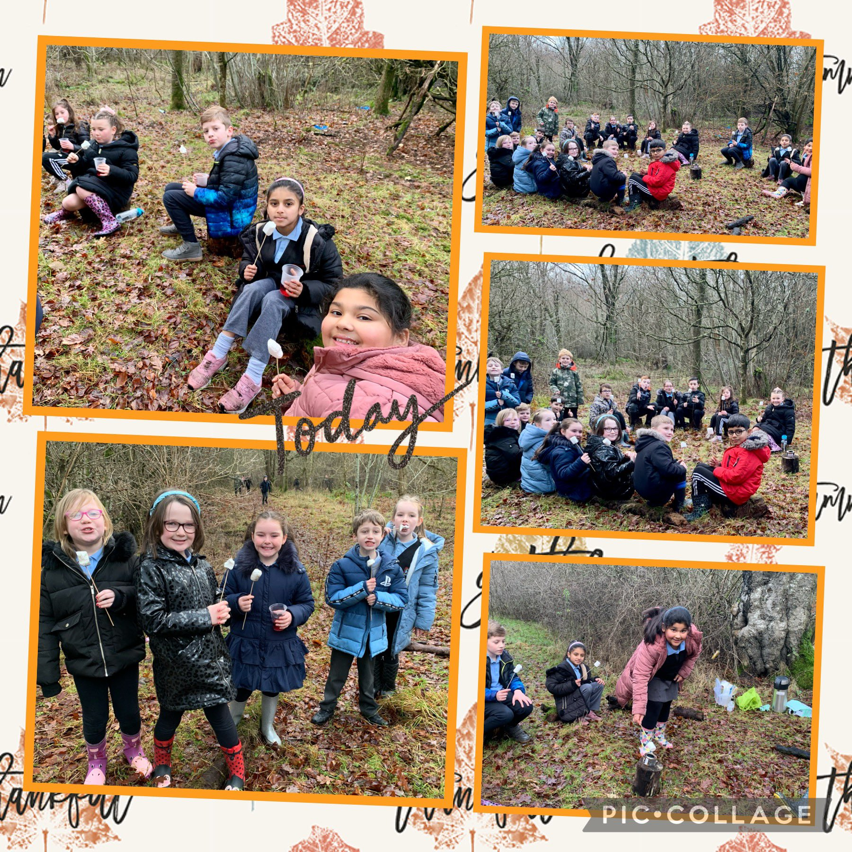 | Multi-Sports  Every-day at lunchtime the P7’s have a group called multi-sports when infants from P1-P5 go to the playground after they finish their lunches and have a fun time, playing with the P7’s. They play with bean-bags, hula-hoops, and lots of more fun equipment. They also play amazing songs from Frozen, Moana, and Toy Story.  Pupils from the wellbeing group wrote articles during the October Holidays and the Editor Team selected parts of their articles to create our stories.  The Editor Team also typed up this newsletter.  Thank you for all your hardwork in Terms 1&2. We will continue to tell you about our Health and Wellbeing and Outdoor Learning Next Term.  Mrs McIntyRe
What some of the children like about going out
Most children love going out a lot, they really like to get some fresh air and they feel better than they were before they had went out.
Here are some reviews from some children:
“I love going out to the park on well-being Wednesday, I really like it and I am hoping to do it more.”
“I go out to the Coby sometimes and I enjoy it a lot because I see lots of animals like e.g. Robins, Birds, Deer, Ladybugs and lots of more bugs and lots of other Birds.”

Some of what the children want more of:
“I really want more of the dance visitors, I really like to dance and it was extremely fun to do.”
“I really enjoy feeding the birds with seeds and planting plants with seeds.”

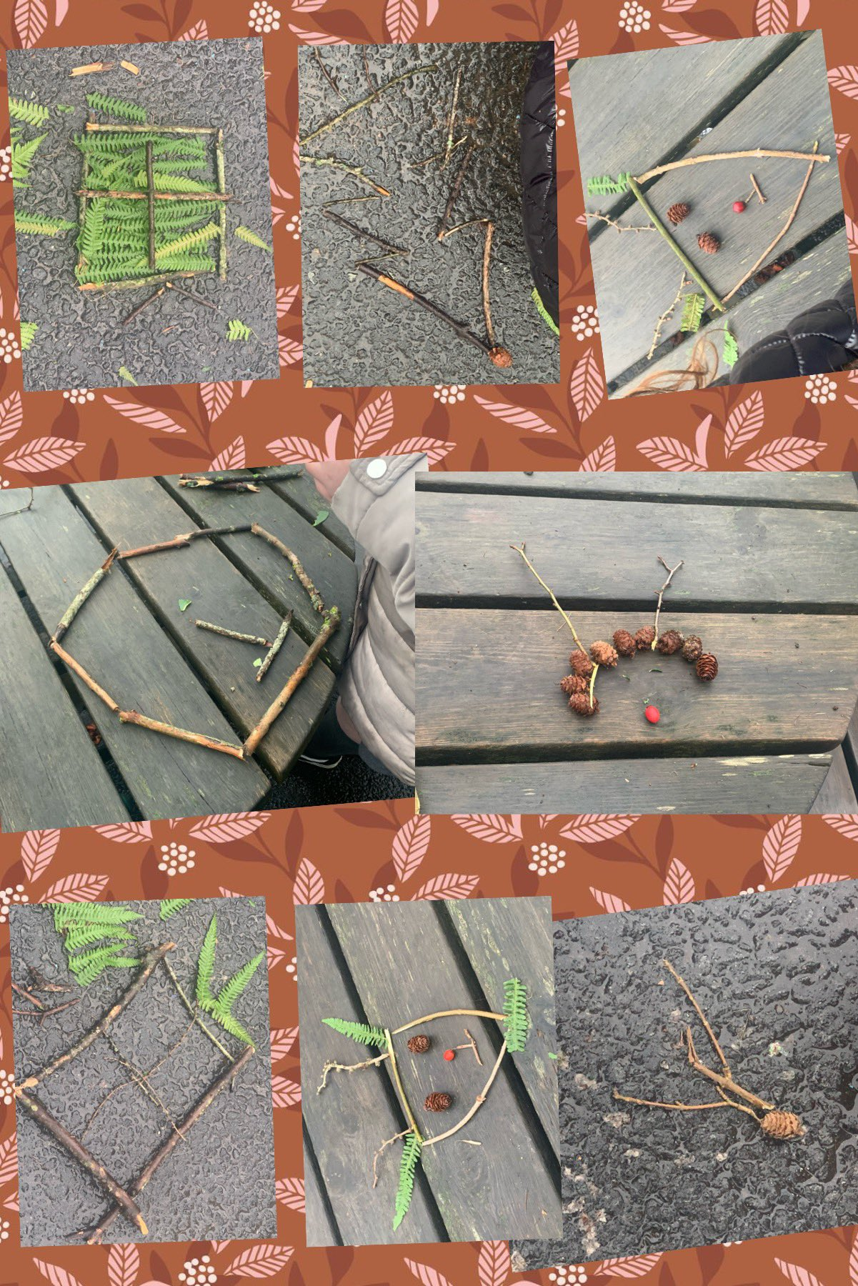
What some P6-7’s did on Wellbeing Wednesday recently.
A few weeks ago on Wednesday, P6-7 went to the Coby and collected stones, sticks and leaves in all in different shapes and sizes to create Christmas decorations. We made some Christmas Trees, Antlers, Snowflakes and Rudolph.

By Amina Mohammed and Zainab Tahir (P7)

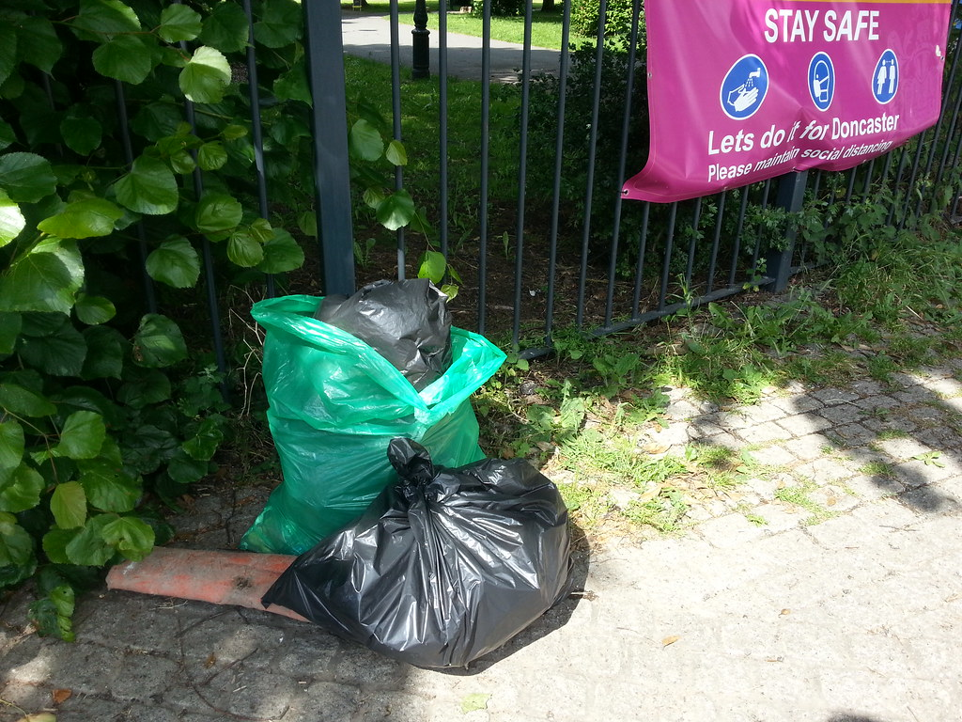
This Photo by Unknown Author is licensed under CC BY

Litter Picking

In our school some of our children enjoy litter picking. It helps them bond with their friends and it help to look after our school environment it . It gets our pupils out in the fresh air and they find it peaceful and it helps them think. It also gives them a chance to get close to nature.
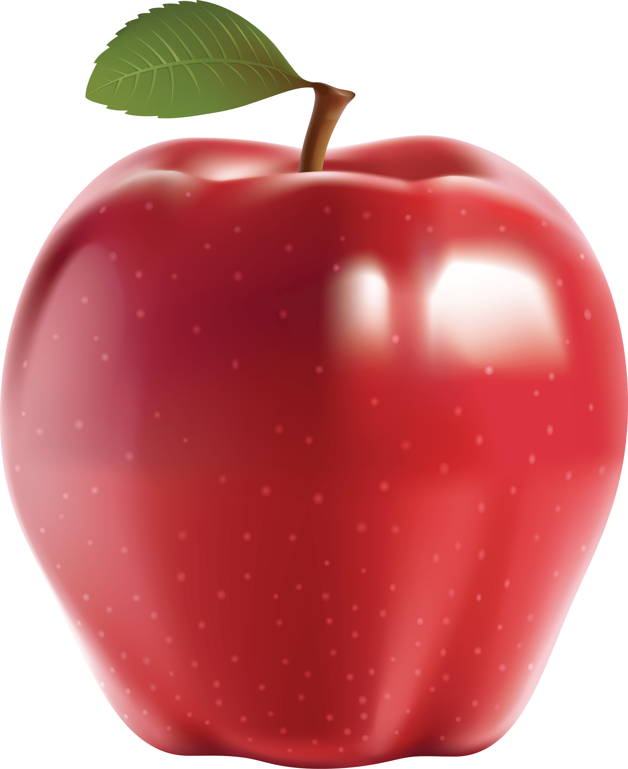
FRUITY FRIDAY
Here at St. Patricks we have Fruity Friday. We all bring in fruit and vegetables. W would normally have sweets on Fridays but on Fridays, one piece of fruit or vegetables equals one sticker .We all think about how fast our sticker charts would fill up if the menu at lunch stayed the same but instead of sweetie treats we had more fruit. We would like a combination of oranges, strawberries and apples. Some people think it is definitely the best day of the week.

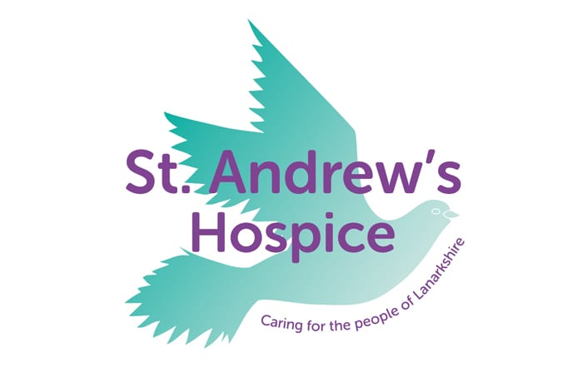
CHARITIES

This year, St Patrick’s have been very generous to St Andrew’s Hospice. Some pupils from P7 made loom bands and children from all classes brought in 50p to buy one. They donated all the money to St Andrews Hospice.
P7’s are sold raffle tickets and colouring sheets for 50p. By buying a raffle ticket pupils were entered into the raffle to win a Christmas gift basket . Pupils coloured it in and wrote a lovely message on the back for the St. Andrews hospice patients. Cass teachers picked the winner from their classes to win a prize , and a couple of people with the nicest colourings and messages on the back of sheets sheet were sent to St.Andrew’s Hospice to cheer up the patients. We wanted them to see and read our messages.

By Orlaith McMenemy and Lucy Close P5

Type a quote from the document or the summary of an interesting point.
Company Address

