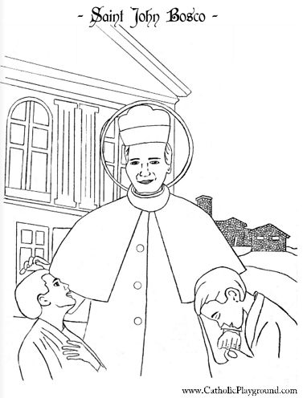

Saint John Bosco Feast Day 31st January

