NLC Literacy Learning at Home Tools for Reading

- Read the story of ‘wh’.

- Pick out the phoneme words by highlighting or underlining the words.

- Write the phoneme words in a list.

The story of ‘wh’
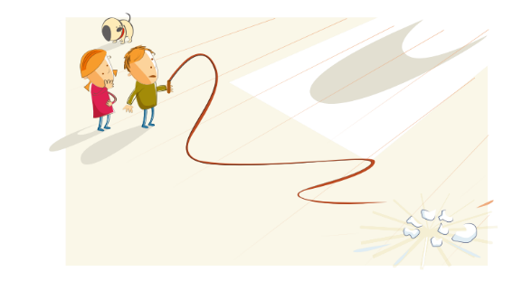
One day while Ben, Belle and Dasher were waiting for Mum to come back from the shops, they took down Uncle Fred’s old cowboy whip from the wall and they began to whirl it around. Whack, whack, went the whip and it knocked Mum’s favourite china whale from the shelf!
“Oh dear,” said Ben. “Where can we hide? Here comes Mum!”

- Use a magnetic board or write out the words from the list and cut them up to word build. Use the 5 finger approach below.

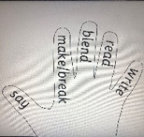
Say, Make, Break, Blend, Read & Write

Say the word | whip
Make the word (find the letters and make the word) | whip
Break the word | wh i p
Blend the word | wh i p
Read the word (moving your finger along letters as you read) | whip
Write the word | whip

- Choose 3 of your phoneme words from the list and write a sentence for each one, highlighting the phoneme words in green and any of your common words in yellow.

