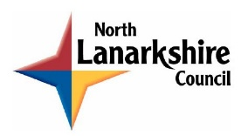**NLC Maths and Numeracy Learning at Home**

**First Level: Money**

Ticket Prices

How much will each group of people pay at the theme park?

**Ticket Price List**

Adults £14

Children Half the adult price

Seniors (over 65) £3 off the adult price

**SPECIAL OFFER Spend over £50 and get a £5 discount**

|  |  |
| --- | --- |
|  |  |
|  |  |
|  |  |

How much would your family pay?