NLC Literacy Learning at Home
First Level Tools for Reading

- Read the story of ‘ey’ (money).

- Pick out the phoneme words by highlighting or underlining them.

- Record the phoneme words in a list.

- Choose 5 of your phoneme words from the list and write a sentence for each one, highlighting the phoneme words in green and any of your common words in yellow.

The story of ‘ey’ (money)
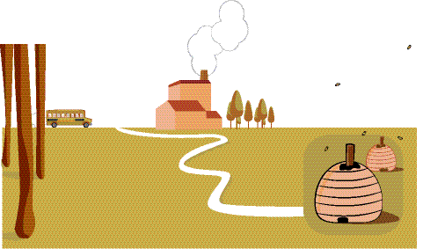
The children were on a school trip to learn where honey comes from. After a short journey the bus reached a green valley. They spotted smoke coming from a chimney so the class knew they had arrived at the farm.
The bee keeper came to meet them.
“We are going to see the bee hives now, so you must obey my instructions. We need to be careful near bees.”
“How exciting!” said Belle to Ben.

