NLC Maths and Numeracy Learning at Home
First Level: Money
Coins and Notes
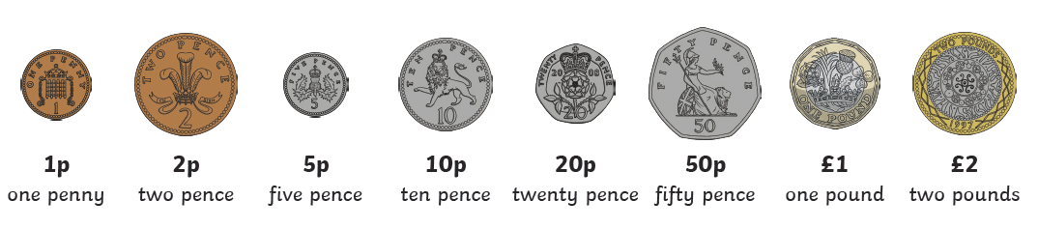
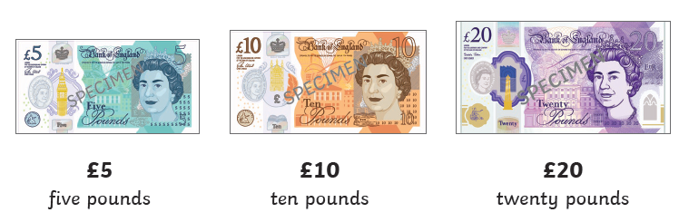

Using combinations of coins and notes, how many ways can you make the following totals? Try to find at least 3 ways for each.
Draw/write the coins and/or notes you would need each time.

75p | £2.00 | £18.54 | £5.99 | 87p | £12.56
59p | £12.33 | £4.59 | £3.50 | 46p | £8.99
£7.90 | 65p | 99p | £14.99 | £17.60 | £6.66
£19.45 | £8.43 | £1.55 | 37p | £8.00 | £11.76

