NLC Literacy Learning at Home
First Level Spelling (Stage 4): Unit 4 ‘The Phoneme Story of oe’
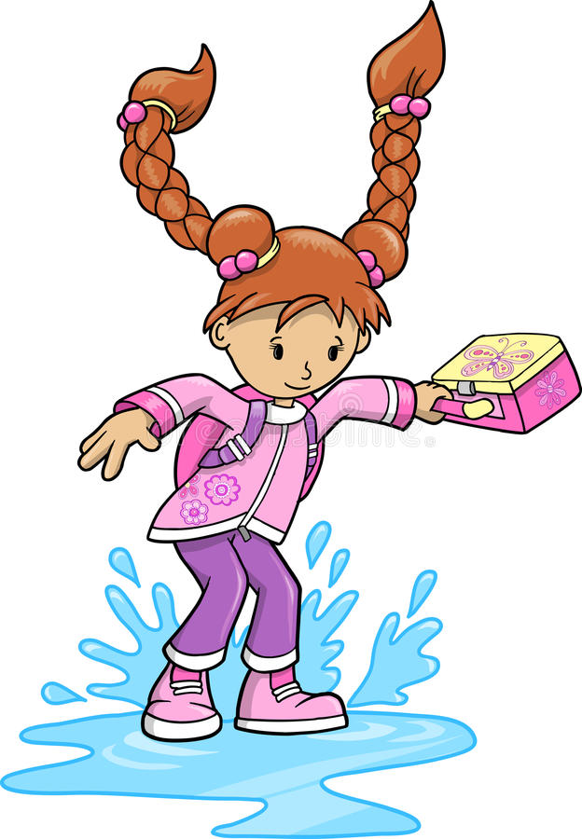

This story contains different representations of the ‘oe’ sound. A representation is a written sound. In this story, we are focusing on ‘o-e, oa, ow and oe’.
Unit 4 Phoneme Story (Core)
During the night it had been raining heavily and I could hear the rain battering against my window. Tomorrow the roads will be flooded with so much rain falling.
Next day I was on my way to school as usual. There were puddles all over the roads and the playground, so I thought I would have a bit of fun. I put my toe into a large puddle which I thought was quite shallow. Well, next thing I knew I was soaked right up to my ankles. There was no one around at the time and I was alone. I didn’t know what to do. As I began to walk, the water was running out of my shoes. I was so miserable, I started to groan as my feet were frozen.
Thankfully, I was given a change of socks and a pair of gym shoes to wear in class. The teacher said she would telephone my mother to bring shoes at home time. My shoes were completely soaked and would take a long time to dry out. I will keep away from those puddles in future.
Task 1
Choose one of the above paragraphs. Dictate it to your child, one sentence at a time. If the sentence is long, read aloud part of it and allow your child time to think about what they are writing.
Correct the paragraph together. Look carefully at any mistakes. Talk about the part they found tricky and look at any misspellings together. Ask your child to practise writing the word again 3 times.
Task 2
Ask them to write a paragraph of their own. They should include at least 2 words that contain the ‘oe’ representation (this can be o-e, oa, ow and oe).
Unit 4 Phoneme Story (Extension – suitable for pupils who require challenge)
The family had gone to bed in their upstairs flat after having poached eggs on toast for their supper. The older son was alone in his bedroom. He woke to the smell of smoke drifting under his nose. He began to choke. Thinking quickly, he closed the hall door as smoke goes everywhere. He raised the alarm and soon the whole household was wakened. It was his hope that they would be able to escape.
Smoke was seen flowing from a hole in the cupboard beside the kitchen. They managed to follow the dim light and reach the telephone to get help. A bit of bread had stuck in the toaster and had caught fire. The young boy thought he could soak a cloth and throw it over the toaster, but as he put his toe in the door he was beaten back by the intense heat. He didn’t know what to do. Then he spotted an open window.
‘Follow me!’ he yelled.
Thankfully neighbours heard their shouts and had gathered on the road outside the house. A brave pair of men went to borrow a ladder to bring the family to safety. The family managed to crawl through the open window to safety.
Those two men were heroes!
So take note! Fire can be a deadly foe! Always check the house at night and keep safe.
Task 1
Read the story aloud. Ask your child to record the words that contain the ‘oe’ representation (this includes o-e, oa, ow, oe).
Task 2
Choose two of the above paragraphs. Dictate it to your child, one sentence at a time. If the sentence is long, read aloud part of it and allow your child time to think about what they are writing.

Correct the paragraph together. Look carefully at any mistakes. Talk about the part they found tricky and look at any misspellings together. Ask your child to practise writing the word again 3 times.

Task 3
Re-read the phoneme story and stop at the end of the third paragraph. Ask your child to write a fourth paragraph of their own. They must use at least 3 representations of ‘oe’ and 3 common words! Correct it together.

