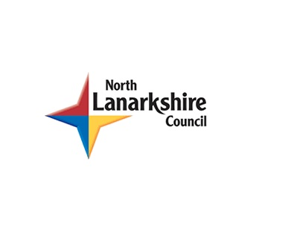 NLC Literacy Learning at Home
Purple Level Reading Task: ‘Dinosaur Safari’
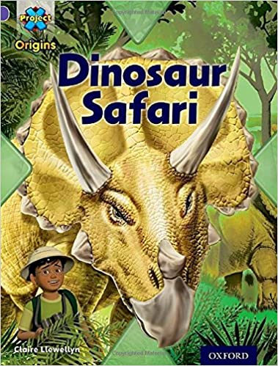
To access electronic Reading Books:
- Log into Oxford Owl. To access the site click here. Parents/carers will need to register. You should click on eBooks.
- Click on ‘Oxford Owl for Home’. Select ‘Enter Site’.
- Select ‘Browse eBooks’. Double click on this.
- Under ‘Browse the eBook library,’ go to ‘Browse by Oxford Level’. Select the colour of the Book Band your child is working at.
- All of the books you can see should be suitable for your child. The process laid out below would be suitable for any of these books.
To use the eBook:
- To turn the pages, use the arrows.
- To hear the story being read, click on the ‘Audio’ arrow
Note to Parents/Carers
- Before reading the book with their child, parents/carers should familiarise themselves with the characters and storyline by reading it themselves first.
- The Word Attack Strategies are attached to this guide. Encourage your child to use the stepping stones if they become stuck at a word.
- There is no need to correct every mistake. Pay particular attention to common words (e.g. the, my, where, and and etc.) and encourage your child to use picture clues to help with tricky topic words (e.g. fence, helicopter, snowman etc.).
- Children should be encouraged to re-read texts. This helps self-esteem and provides additional fluency practice.
- Above all, reading should be fun! Help your child to have an enjoyable experience.
There are 3 main parts to this Reading activity!
Part 1: Walk through the text with your child (this helps their understanding before they read)
- Look at the front cover. This is a non-fiction book. Point to the title. This book is called ‘Dinosaur Safari’. Look at the illustration. What can you see? What is this book going to be about?
- Contents Page This is the part of the book that tells you what topics are included and the page that you can find them on.
- (P2 & 3) If you would like to explore the past, there are pages in this book that will help you. You can find out about animals that lived on the land, creatures that swam in the sea and those that flew through the air. This is the photo of a fossil. A fossil is animal bones and shells that have turned into stone. Point to the word ‘creatures’ in the text.
- (P4 & 5) This diagram shows you the earth as it was 100 million years ago. It was warm and dinosaurs roamed the earth. Point to the Brachiosaurus and the Tyrannosaurus. Point to the word ‘safari’ in the text.
- (P6 & 7) Here is a herd of Brachiosaurus. It has a very long neck that can reach to the top of the trees. Look at its skeleton.
- (P8 & 9) This is a group of Triceratops. They feed on leaves and twigs. It has 3 horns on its head. It will use these to both attack other animals and defend itself. Read through the labelled body parts with your child.
- (P10 & 11) Some predators roam in muddy swamps. They can hunt for food here. This is the Tyrannosaurus. It has a massive head and jaws. Read through the labelled body parts with your child.
- (P12 & 13) The Maiasaura dinosaur used to visit sandy beaches every year to lay their eggs. A female can lay up to 30 eggs in a nest. Look at the illustration with your child.
- (P14 & 15) These pages tell you about the animals that lived in the sea. Sea birds, sharks, turtles and ammonites all lived in the sea. Look at the diagram with your child.
- (P16 & 17) The Elasmosaurus lived in the deepest part of the sea. It had a huge neck that is 15metres long. Point to the word ‘escape’ in the text and read it aloud.
- (P18 & 19) A huge flying reptile was the Pteranodon. It had wings that were covered in skin. Long ago, moths, honeybees, birds and insects were other flying insects that could be found on earth.
- (P20 & 21) The Pteranodon would leap off cliffs and dive into the sea for food. They were bigger than any flying creature that we see today.
- (P22) Talk to your child about the animals on this page and discuss where they lived – in the land, air or sea.

Part 2: Fluency
Solo Read
- Ask your child to read the book. They can use a pointing figure to track the words.
- Support them with any tricky words. Use the Word Attack stepping stones to help them.
- Give them praise at the end!
Partner Read
- Now read the book with your child!

Audio Read
- You can select the ‘Audio’ setting on the eBook and your child can read along.
Record your reading
- It can be helpful to occasionally record your child reading. This can be on a phone or an iPad. Allow them to listen to themselves. Ask them to comment on their reading, talking about what they did well and what they might try to improve on next time.

Part 3: Comprehension (checking understanding)
- Check that your child has understood the story by talking to them about it.
Ask them to tell you what happened and who the main characters were. Go back to the story and ask them to point to the characters and use this as an opportunity to revisit some of the common words.
After Reading
- You could encourage your child to try some of the Play Activities. These are directly above the eBook that they have just read.

Word Attack Strategies
I can use these stepping stones to help me read words.
II
Look at the first letter
Sound out the first few letters

Break the word into syllables

Look at the last letters
Look at the shape of the word
Look for a rime
Look at the picture
Read the sentence again

