NLC Literacy Learning at Home Tools for Reading

- Read the story of ‘ng’.

- Pick out the phoneme words by highlighting or underlining the words.

- Write the phoneme words in a list.

The story of ‘ng’
It was the night of the school concert. Belle was going to sing a song and Ben would play his guitar. On stage Belle was singing at the top of her lungs. That’s when it all went wrong. Ping! One of the strings on Ben’s guitar broke. Belle was so shocked she couldn’t sing a thing. They had to hang their heads and leave the stage. How embarrassing!

- Use a magnetic board or write out the words from the list and cut them up to word build. Use the 5 finger approach below.

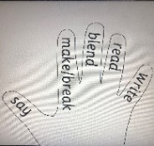
Say, Make, Break, Blend, Read & Write

Say the word | sing
Make the word (find the letters and make the word) | sing
Break the word | s i ng
Blend the word | s i ng
Read the word (moving your finger along letters as you read) | sing
Write the word | sing

- Choose 3 of your phoneme words from the list and write a sentence for each one, highlighting the phoneme words in green and any of your common words in yellow.

