NLC Maths and Numeracy Learning at Home
First Level: Patterns and Relationships
100 Square Patterns
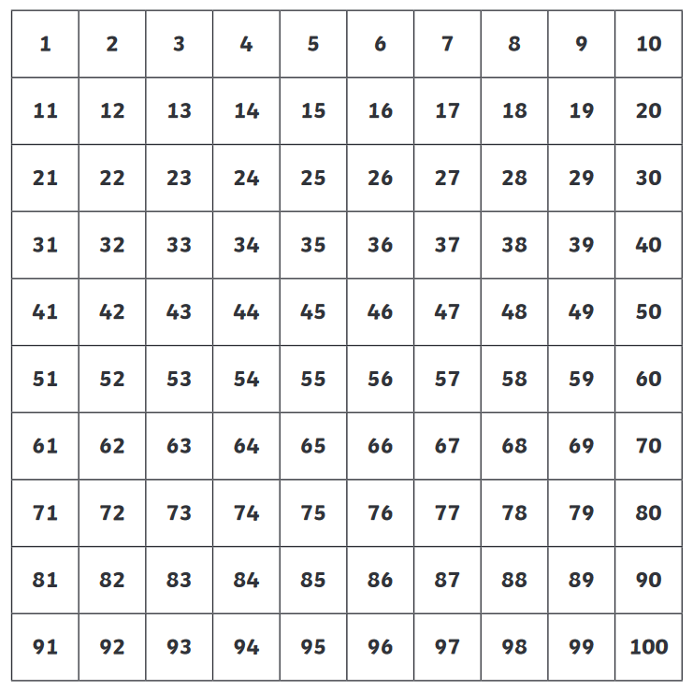
Colour all the numbers in the 2 times table red
Colour all the numbers in the 5 times table blue
Colour all the numbers in the 10 times table green
What patterns do you notice?
Find another number pattern and colour it yellow. Can you get someone to work out what your pattern is?

