**NLC Maths and Numeracy Learning at Home**

**First Level: Fractions, Decimal Fractions and Percentages**

**Fractions**

Colour the shapes to match the fractions

|  |
| --- |
|  |
|  |
|  |
|  |

$\frac{1}{4}$ blue

$\frac{2}{4}$ red

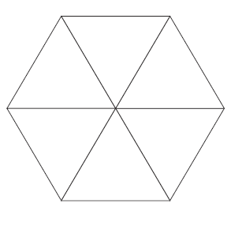

$\frac{1}{6}$ blue

$\frac{2}{6}$ red

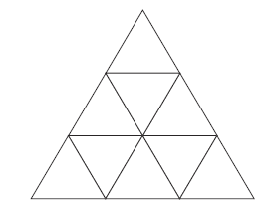

$\frac{3}{9}$ blue

$\frac{5}{9}$ red

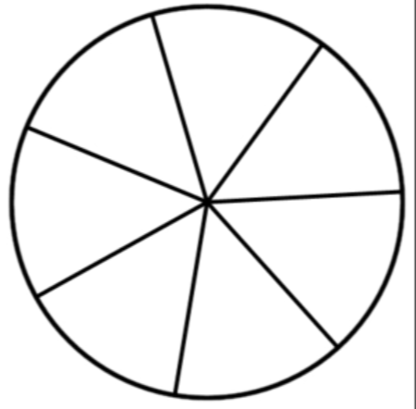

$\frac{1}{7}$ blue

$\frac{2}{7}$ red

$\frac{3}{7}$ green

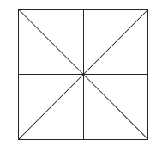

$\frac{1}{8}$ blue

$\frac{3}{8}$ red

$\frac{2}{8}$ green

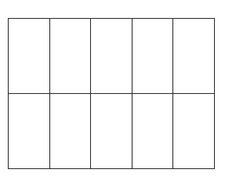

$\frac{2}{10}$ blue

$\frac{3}{10}$ red

$\frac{4}{10}$ green