Timetables

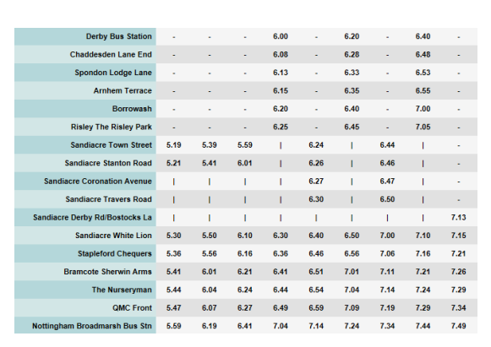
Practise

- What time does the bus from Sandiacre Town Street first begin in the morning?
- What time does the first bus leave Derby Bus Station at?
- If I catch the bus from Borrowash at 6.20, what time can I expect to be in Nottingham for?
- If I catch the bus from the Sherwin Arms at 7.11, what time will I get to QMC for?
- If I want to catch the bus from Bostocks Lane what time will I be able to get the bus?

Fluency
- If I catch the bus at Sherwin Arms at 6.21, how long will it take me to get to Broadmarsh?

- Can you travel to Coronation Avenue on the 6.20 bus?

- Which journey from Sandiacre Town Street to Broadmarsh takes the longest time, the bus that leaves Town Street at 5.59 or the bus that leaves at 6.24? Why don’t they take the same amount of time?

- If I catch the bus at Stanton Road at 6.46, how long will it take me to get to Sherwin Arms?

- If I catch the bus at Arnhem Terrace at 6.15, how long will it take me to get to Broadmarsh?

- If I catch the bus at Town Street at 6.44, how long will it take me to get to QMC?

Reasoning
- Which journey from the QMC to Broadmarsh is the quickest? Why do you think it may be the quickest?
- Which journey from Town Street to Broadmarsh takes the longest?
- If you needed to travel from White Lion to Broadmarsh and had to arrive by 7.17, which bus would be the best to catch? Explain your answer.
- Hannah works a 10 minute walk from Broadmarsh. She has to start work at 7.30. She is on the 6.56 bus from Chequers which is running 8 minutes late. Will she make it to work on time? Explain your reasoning.

Problem Solving
- Order the journey times on the timetable from Town Street from longest to shortest.
- Three trains travel from Halifax to Leeds on the same morning. The Express leaves Halifax 10 minutes after the All Stations train, but arrives at Leeds 10 minutes before it. The All Station train takes 50 minutes to reach Leeds and arrives at 10:30. The Goods train leaves 20 minutes before the All Stations and arrives at Leeds 20 minutes after the Express. Work out the timetable. That is; what time does each train leave Halifax and what time does each train arrive at Leeds station.

