NLC Maths and Numeracy Learning at Home
First Level: Time
Using a calendar
A calendar is used to show the days, dates and months in a year.
Can you find any calendars in your house? Some phones have calendars on them too. Have a look at calendars with someone in your house talk about them.

Using these calendars, answer the questions.

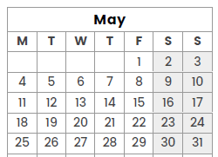 | What day is the 12th of May?  What date is the last Monday in May?  What date is the second Saturday in May?  What day is the last day of May?
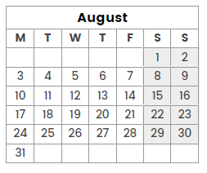 | What day is the first day in August?  What day is the 7th of August?  How many days are there in August?  What day is the 20th of August?  Write the second Wednesday in August using words and numbers.
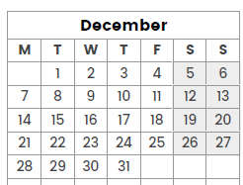 | What day is the 10th of December?  What date is the second Sunday in December?  What day is Christmas Day?  What day is New Year’s Eve?

With someone in your family, write a list of all the birthdays in your family. Can you put them into a calendar?

