NLC Literacy Learning at Home
First Level Tools for Reading

- Read the story of ‘tch’.

- Pick out the phoneme words by highlighting or underlining them.

- Record the phoneme words in a list.

- Choose 5 of your phoneme words from the list and write a sentence for each one, highlighting the phoneme words in green and any of your common words in yellow.

The story of ‘tch’
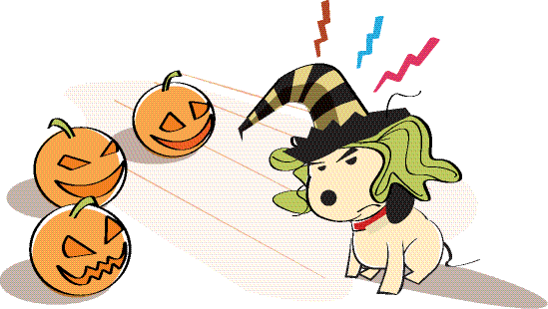

It was Halloween, and Ben was dressed up as a witch. He wore a green wig which made him itchy. He took off the wig to scratch his head and left it on the kitchen table.
Dasher tugged at the edge of the wig and pulled it down onto his head. He tried to pull it off with his teeth. Ben and Belle laughed so much when they saw him.
“What a twitchy witch!” said Ben.

