NLC Maths and Numeracy Learning at Home
Second Level: Expressions and Equations

Work out the value of each of the symbols.

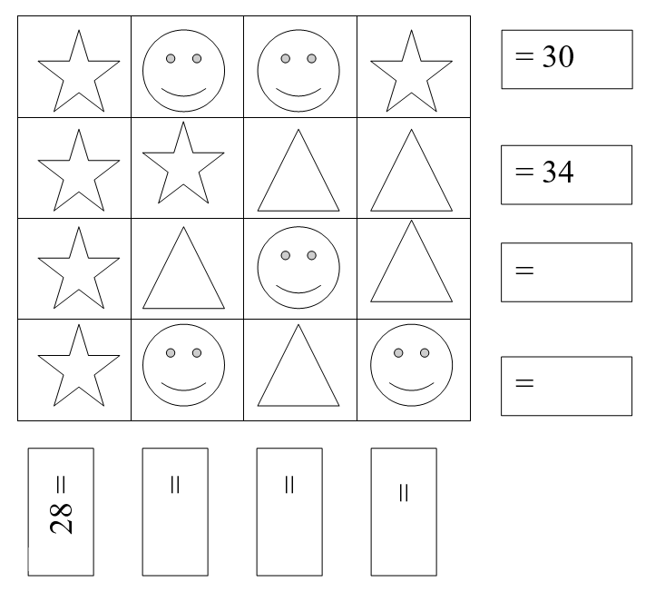

Create your own symbol problem for someone in your family to solve.

