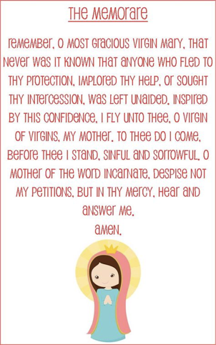

May is the Month of Mary.

The Memorare is a prayer we would have learned and said every day during the month of May.

Maybe you could print and cut out the little prayer card and say it each night before you go to bed.

Maybe this week you could research The Joyful Mysteries.