NLC Maths and Numeracy Learning at Home
Second Level: Time

How long will each activity take? Estimate how long and then carry out the task or investigate the answer using Google.

Do 20 star jumps | Read a book
Walk from Coatbridge to Airdrie | Fly from Scotland  to Australia
Boil an egg | A holiday in Spain
Play a game | Watch a film

What is the most appropriate unit of time to measure each of these activities?
Seconds
Minutes
Hours
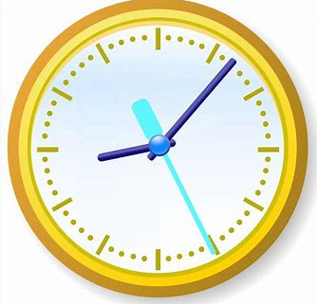
Days
Weeks

