1.05.20 Good morning to Mrs Slavin's children.
Wow! Can you believe it's Friday again boys and girls?
Can you believe it's the first day of May? During this month we can enjoy seeing all the beautiful flowers and take time to think about Mary Our Blessed Mother. Here's a short clip of children saying Our lady's special prayer:
https://youtu.be/TUw4tjsBCmg
The children in the clip have drawn pictures to illustrate the prayer. Can you draw a picture to show your favourite line of the prayer?
or use the link and carefully colour this lovely picture of Mary

our lady

We usually go for P.E after 9am today so this little dance routine should keep you moving. Enjoy!
https://youtu.be/ymigWt5TOV8
For Maths, here's a worksheet for Primary 2 children. Can you complete the pattern?

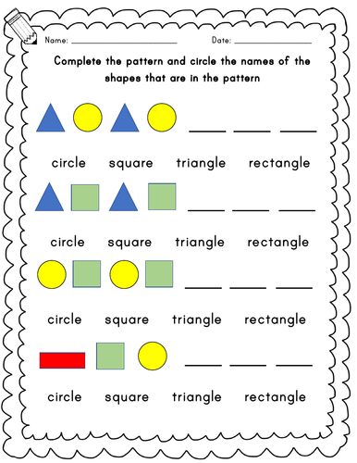
Primary 3's could you have a go at this one?:

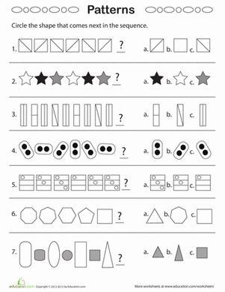
Last week I showed you a picture of Harry the snail. Did you find any interesting animals in your garden?
We had another look and discovered a little beetle. Here he is ...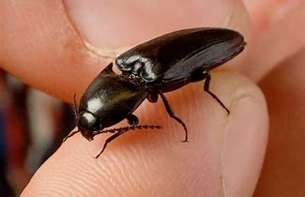
So have a look in your garden to see how many mini-beasts you can find today? Use this worksheet to help you record your observations
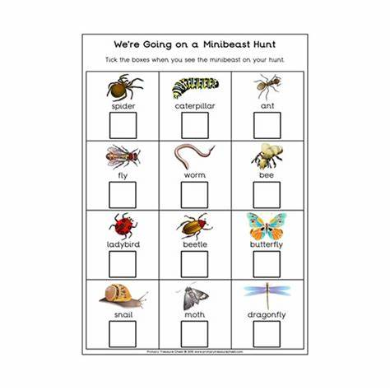Have a lovely Friday children and don't worry about the tasks, they're onlysuggestions.Hopefully you'll get out to play and have some fun.Remember to let Mrs Slavin and I know how you're all getting on. It was great to hear from Mark.
God Bless
Mrs Moore x

27.04.20 Hello boys and Girls, how are you all today?
It has been such a lovely week last week so I hope you all managed to enjoy some of the nice weather.
It is going to be cooler this week so make time to cosy up with your favourite book or even a family film! I have put up a clip of The Lion and the Mouse but there are others you could listen to or get someone to read to you!
The Sunday Gospel was about The Road To Emmaus watch one of our 2 little Bible stories below, can you think of God's message. We are on a different journey that no one expected why don't you write down some of the things you are doing that are new. My husband and daughter Niamh ran the 2.6 mile challenge on Sunday to help others, what can you do to help even your mum around the house? Let me know what you all get up to I would love to hear from you!https://www.youtube.com/watch?v=5ucK3U3nnOI&t=8shttps://www.youtube.com/watch?v=PG1LjFO99dA

This week in Spelling you would have been working on these:

Red Group Common Words write answer began heat page
Phoneme oe toe hoe goes heroes doe potatoes tomatoes foe

Blue Group Common Words every find want girl
Phoneme o-e home rope stole awoke hope smoke

Green Group Common Words this that then
Phoneme th the this that then there these their them

Feel free to do the above or continue to do a few words each week from the list I gave you all in your pack.
Try to see how many of your common words or phonemes you can find in the book you choose to read this week. Try and get someone to test you on your words on Thursday. Good luck!
We were all learning to tell the time in school last term so here are a few clips to remind you what to keep working on at home with your family.

Let's Learn About the Clock | Fun Clock Song for Kids | Jack Hartmann

Rock and Tell the Time on the Clock | Analog & Digital Clock Song for Kids | Jack Hartmann

If you can get some exercise outside but why don't you try one of the following also:
www.joewicks.com or bbc.co.uk/bitesize or
https://www.youtube.com/watch?v=rnlDBKD2S78
Thursday is the last day of the Month and we haven't seen you all in April, send us a picture of you doing something in the garden or with your family we would love to see them.
Take care boys and girls. God Bless Mrs Slavin x

