NLC Maths and Numeracy Learning at Home
Second Level: Number and Number Processes

Multiplication – Arrays
We use arrays to represent times tables. They are made of rows and columns.
Here are some examples.
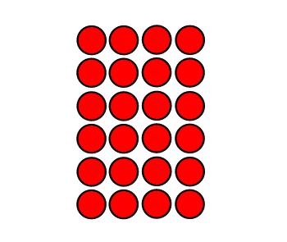
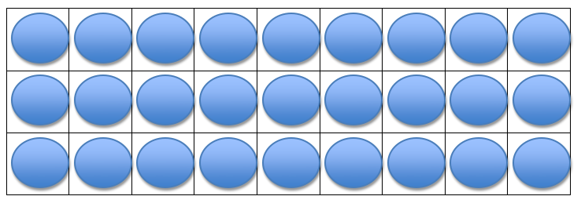
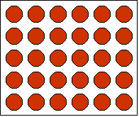

Array of 27 Array of 24 Array of 30

A number can have many arrays. For example, the number 20 could have the following arrays:
1 row of 20 dots (1 x 20 = 20)
20 rows of 1 dot (20 x 1 = 20)
4 rows of 5 dots (4 x 5 = 20)
5 rows of 4 dots (5 x 4 = 20)
2 rows of 10 dots (2 x 10 = 20)
10 rows of 2 dots (10 x 2 = 20)

Draw as many arrays as you can for these numbers.
48
12
40
16
36

