First Level Literacy Home Activities
Listen or logon to Newsround on CBBC. Listen to/read one news article. Note the main points/facts and use them to retell to a member of your family. | Choose a short book or a chapter of a book and read aloud for a member of your family to enjoy.  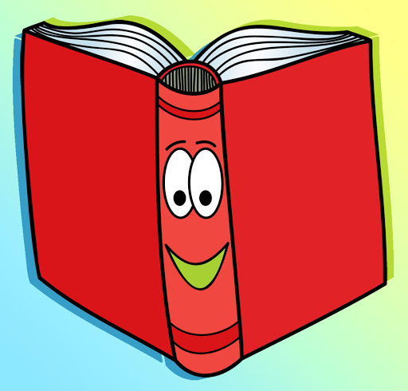 | Retell a story, in your own words and in the correct sequence. Tell someone what you enjoyed, found interesting and why you liked/disliked the text. | Retell a story in your own words, using drama, props & puppets.  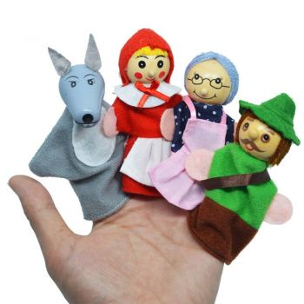
Create your own story with a beginning, a middle and an end. | Log on to Sumdog Reading & Spelling. How many questions can you correctly answer? | Create a menu, birthday/special occasion card, postcard, letter, invitation, sign or label. | Keep a diary for five days. Write three paragraphs telling your reader what you did in the morning, the afternoon and in the evening.  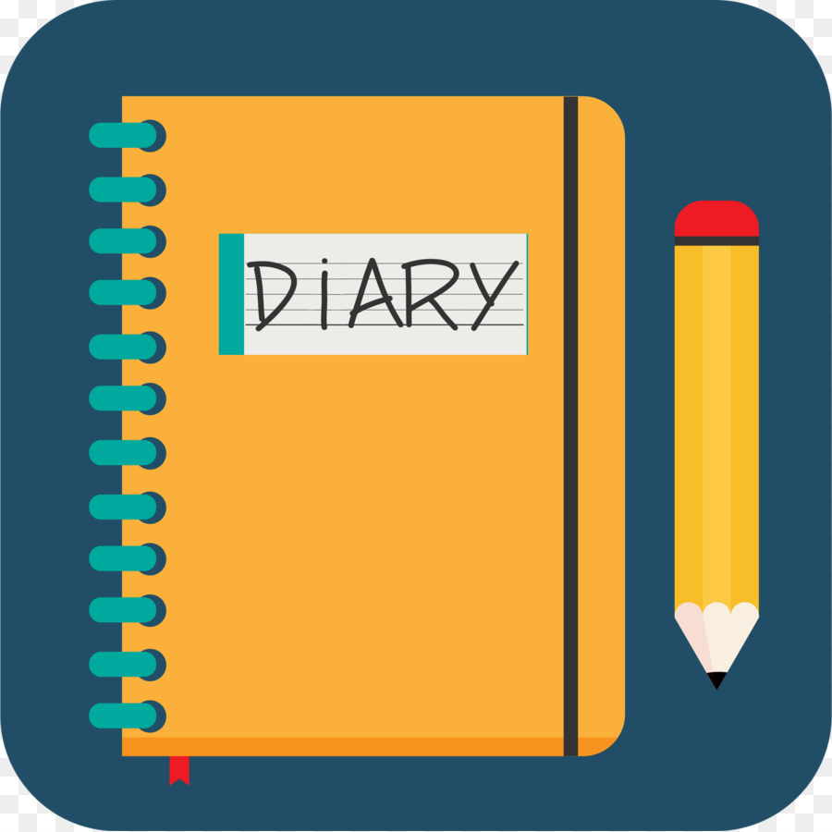
Select a few stories from the news and make notes then write about these in your own words. | Write a rhyming poem about any subject of your choice.  Re-write it as a ‘Shape Poem.’  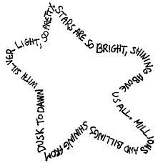 | Write a letter to a friend or relative  Giving details of what you have been doing and find out what they have been doing. (Include illustrations or diagrams)  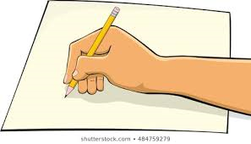 | Choose a short story or a chapter from a book.  Make a comic strip with pictures and sentences to describe main points of the story/chapter.  Give it to a family member to read/and or read aloud.  