Primary 3 Newsletter
March 2025 – Term 3

Dear Parents and Carers,
The children are now approaching the last term of Primary 3. We have a very important term ahead and this positive and enthusiastic start to the term will ensure they are able to achieve their full potential in preparation of them moving to Primary 4.
We have so much happening in this busy term and this newsletter will give you an insight into some of what is going on in your child’s class:
Curriculum

Literacy

During this term we will be carry out various reading activities as well as focussing on punctuation and grammar. We will be working on fiction texts. The children will continue what they have learned in terms 1 and 2 and develop their knowledge in more complex texts.
Numeracy

We will be focussing on Fractions, Percentages, Decimals and Data Handling. The children will learn these concepts through both active and independent activities.
Children are encouraged to work on their number sequencing throughout the year. It is extremely important that they keep up their number ordering, number bonds and sequencing practice at home. This will help during tasks in class such as Number Talks and Mental Maths.

Topic
This term our topic is Rights and Responsibilities of People in Society. We will be exploring the difference people in our society. If you have any resources you are willing to share, we would take great care of them and this would bring the topic to life for the children. We will focus on the Children’s Rights articles within the United Nations Convention for the Right’s of the Child, and how they relate to children and people in our society.
Other Curricular Areas

Library – Wednesday
ICT- Thursday
Homework
Details for our homework will continue to be displayed on our class teams. You will find the weekly homework, issued on a Friday, in the ‘class materials’ folder and the homework will be dated for that week. The homework will consist of Spelling, Reading, Maths. All work carried out at home is a reinforcement of the learning in class.
It is important that all children are on the class team. If you are finding it difficult to access Teams please let me know or contact the school office.
The passcode for the class teams is: a27bmt6

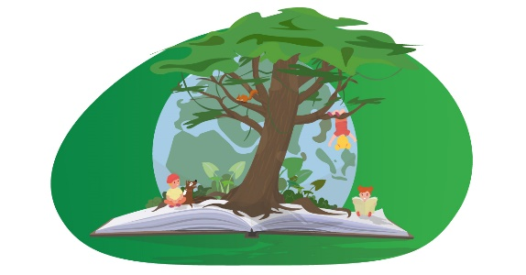
P.E. and Outdoor Learning
Our PE days are Tuesday and Thursday.
The children are asked to bring their green t-shirt and shorts and appropriate shoes (PE kit). Your child can also bring their PE kit into school on a Monday and leave it on their peg for the week, taking it back home on a Friday to wash it.
We currently do not have a set day for Outdoor Learning, if we are going to arrange a day, the children will be given prior notice and I will post on the class team.
Please ensure that all clothing that is brought into the school has the children’s name on it then we can quickly identify who items belong to so things do not get lost in the school.
Please do not hesitate to get in touch if you have any worries, concerns or questions at any point.
Kind regards,
Mr Docherty



