Primary 3 Newsletter
January 2025 – Term 2

Dear Parents and Carers,
We would like to welcome the children back to school after the festive break. The work that they have produced in term 1 has been of a very good standard and we wish to keep this going the rest of the year. We have a very important term ahead and this positive and enthusiastic start to the term will ensure they are able to achieve their full potential.
We have so much happening in this busy term and this newsletter will give you an insight into some of what is going on in your child’s class:
Curriculum

Literacy

During this term we will be carry out various reading activities and concentrating on the children’s core writing targets. We will be focusing on poetry and non-fiction. The children will learn various aspects of poetry and how to develop a poem using different strategies.
Maths

We will be focussing on Time, Measurement, 2D & 3D Shape. The children will learn these concepts through both active and independent learning.
Children are encouraged to work on their number sequencing throughout the year. It is extremely important that they keep up their number ordering, number bonds and sequencing practice at home. This will help during tasks in class such as Number Talks and Mental Maths.

Topic
This term our topic is the Vikings. We will be exploring the difference in their culture and ours. If you have any resources you are willing to share, we would take great care of them and this would bring the topic to life for the children. We would also be grateful if you have any special knowledge on the Vikings, that you would be willing to come in and share with the class.
Other Curricular Areas

Library – Wednesday
ICT- Thursday
Homework
Details for our homework will continue to be displayed on our class teams. You will find the weekly homework in the ‘class materials’ folder and the homework will be dated for that week. The homework will consist of Spelling, Reading, Maths. All work carried out at home is a reinforcement of the learning in class.
It is important that all children are on the class team. If you are finding it difficult to access Teams please let me know or contact the school office.
The passcode for the class teams is: a27bmt6

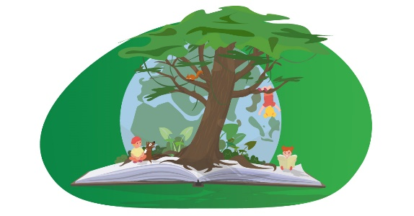
P.E. and Outdoor Learning
Our PE days are Tuesday and Wednesday.
The children are asked to bring their green t-shirt and shorts and appropriate shoes (PE kit). Your child can also bring their PE kit into school on a Monday and leave it on their peg for the week, taking it back home on a Friday to wash it.
We currently do not have a set day for Outdoor Learning, if we are going to arrange a day, the children will be given prior notice and I will post on the class team.
Please ensure that all clothing that is brought into the school has the children’s name on it then we can quickly identify who items belong to and things do not get lost in the school.
Please do not hesitate to get in touch if you have any worries, concerns or questions at any point.
Kind regards,
Mr Docherty



