Primary 7 Newsletter
January 2025 – Term 2

Dear Parents and Carers,
The children have all been working very hard during the first term and have made great progress in all areas of the curriculum. There is so much happening during this busy term and this newsletter will provide you with key information regarding the focus for your child’s learning next term.
Curriculum

The topics which we will be covering across the curriculum this term are:
Literacy – Non-Fiction Reading, Discursive and Persuasive Writing and Narrative Writing.
Numeracy – Multiplication, Division, Fractions, Decimals, and Percentages, Data Handling and Measure.
People in the Past – Conflicts: World Wars I and II
Health and Wellbeing –Raquet Sports, Fitness.
The children will also benefit from weekly Music lessons with Mrs Carrick and weekly ICT lessons with Mrs Devlin.

Homework
Thank you for all your hard work at home with your children, it makes such a difference to their confidence and is very beneficial for their learning and retention. Just a reminder that homework will be issued on a Friday on Teams. Please ensure your child’s reading book is in their bag every day as we do use these daily for written tasks. Homework jotters should be returned to school by the following Thursday where possible.

P.E. and Outdoor Learning
Children are asked to bring their PE kit, including green t-shirt and shorts along with a pair of joggers which can be used for outdoor learning where appropriate. This kit should be brought to school on a Monday and taken home on Fridays.

This is to allow more flexibility within the class timetable and ensures children are always equipped for their learning. During the winter months, a pair of wellie boots and a spare pair of socks are also advised.

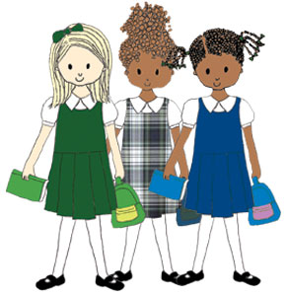
Names and Lost Property
Please could you ensure that all of your child’s clothing has their name labelled clearly on the tags or inside of the item of clothing. Gym days can become problematic when the children change, and items of clothing are left in the classroom.
If you do notice your child has mixed up their clothing with someone else, please return the items as soon as you can so we can swap back.

Beauty and the Beast
Preparations for our Spring Show have begun and the children are so excited! Our Expressive Arts afternoons will being at the end of January where all children will have the opportunity to contribute and participate through Drama, Music and Art.

Sacrament of Confirmation
On Wednesday 26th of February some of our Primary 7 children will receive the Sacrament of Confirmation. Preparations are underway in class, but children are reminded to bring their Confirmation workbook each day.

Please do not hesitate to get in touch if you have any worries, concerns or questions at any point. Thank you for your continued support.
Kind regards,
Mrs Piraino

