Primary 2 Newsletter
Term 2 January 2025

Dear Parents/Carers,

Thank you so much for your continued support in your child’s education. The children are working very well and give their best in all the tasks required of them. I hope we can continue to progress in all that we do.

Homework and Microsoft Teams
The children will continue to use their homework jotters. All children should also continue to access the Microsoft Teams using their Glow username and password. Homework will continue to be issued on a weekly basis. The homework will be posted on a Friday and can be completed at any point over the week and the homework jotter and reading book should be returned to class on the Thursday/Friday the following week.
Outdoor Learning & P.E.
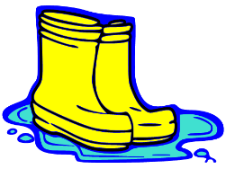
As you know we are very lucky in St Michael‘s to have access to wonderful grounds and a school forest. We are not going to have a set Outdoor Learning Day this term but we would appreciate it if you could provide your child with Outdoor Learning clothes and a gym kit in a bag that can be brought in on a Monday and will be kept on their peg for the week and will be sent home again each Friday. This should include appropriate outdoor clothing (jogging bottoms/leggings, fleece, rain jacket etc.) as this will allow them to be comfortable and enjoy our time outside. If you have wellies these could be sent in too, but we do have a supply of wellies for when they are needed. (If you wish your child’s boots to remain in school then just let us know to save having to return them each week.) Our school PE kit consists of green t-shirt and green shorts however any plain t-shirt and shorts is acceptable.

**Please ensure all items of clothes and footwear are labelled**

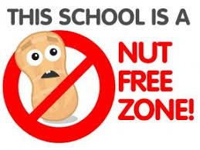
Snacks
We have children in the class with nut allergies and we would appreciate your co-operation in choosing a snack for your child that is nut free.

Names and Lost Property
Children are encouraged to keep all belongings safely in their bag however, we would appreciate if you could ensure names are on each item of clothing and any property such as water bottles and packed lunches. We will also post any property found in class without a name on our class team. Thank you.

Soft Shoes
The children still need to wear soft shoes while in class. This is to help keep the floors clean, especially during these winter months. Please check to make sure the children have soft shoes that fit. Their feet may have grown since August.

Finally, please don’t hesitate to contact us if you have any queries.

Mrs Devlin & Mrs Carrick

