Links to Websites and Additional Supporting Resources

Young Scot - Aye Feel
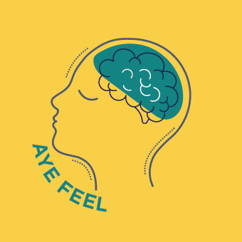

Find information about how to look after your emotional wellbeing, support from organisations around Scotland and tips on how to promote a positive mindset.
https://young.scot/campaigns/national/aye-feel

North Lanarkshire Council’s Psychological Service
NLC’s Psychological Service have put together a wealth of information and support for Parents/Guardians.
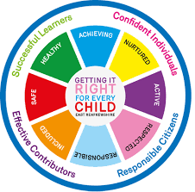
A link to be created here to the attached Shannari documents

Advice for helping children, young people and their families manage their anxiety about COVID-19 – created by NHS, COSLA, RC Psych, YouthLink and Young Scot (19/03/20)
A link to be created here to the attached document

Education Scotland – Scotland Learns

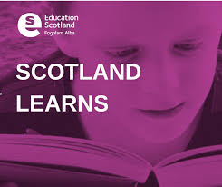

https://education.gov.scot/improvement/scotland-learns/

Clear Your Head Resources

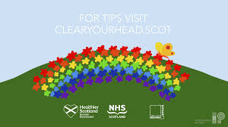

Click on the link below for advice about wellbeing, such as Keeping Moving, Creating Routine, Looking after yourself, Staying connected and Staying Healthy:

https://clearyourhead.scot/

The Anna Freud Centre has also produced a booklet on “Managing unexpected endings and transitions”:

A link to be created here to the attached document

The National Parent Forum of Scotland

The National Parent Forum of Scotland provides excellent material and has produced 3 very good, free resources on:

Learning at Home in Lockdown
https://www.npfs.org.uk/downloads/learning-at-home-in-lockdown/
Online Safety
https://www.npfs.org.uk/downloads/online-safety/
Securing your devices
https://www.npfs.org.uk/downloads/securing-your-devices/

Parent Club

https://www.parentclub.scot

Think You Know Resources

https://www.thinkuknow.co.uk/parents/

https://www.thinkuknow.co.uk/parents/Support-tools/home-activity-worksheets/

