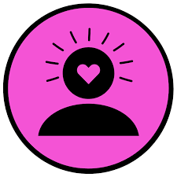
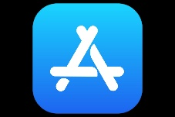
St Maurice’s High School
App Recommendations for Positive Wellbeing
- The following apps are available on the app store and can be sued to assist you with promoting positive wellbeing
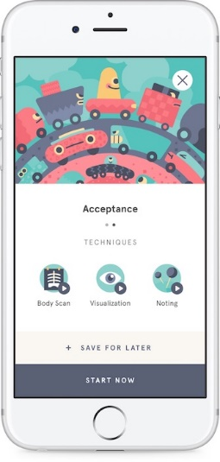
- Some do cost money or have add ons which cost money

1. Headspace

Meditation and mindfulness is made simple with Headspace, the app that counts Gwyneth Paltrow and Emma Watson as fans. Literally giving users a workout for the brain - led by former Buddhist monk Andy Puddicombe - the premise is to take ten minutes a day to listen in and clear your mind. So what are the benefits? Users report better attention spans, alertness and instant calm.

2. Clear Fear
The fear of threat, or anxiety, is like a strong gust of wind. It drags you in and makes you want to fight it or run away.

Instead, face your fear with the free Clear Fear app and learn to reduce the physical responses to threat as well as changing thoughts and behaviours and releasing emotions.
Anxiety is a natural response to fear, threat and apprehension. However when anxiety is extreme or goes on for a long time, or the response to a threat is disproportionately large and affects a person negatively, it may become an anxiety disorder.

Anxiety disorders are the most common form of emotional disorder and respond very well to a form of treatment called Cognitive Behavioural Therapy or CBT.

When you face your fear, you will reduce the threat and glide.
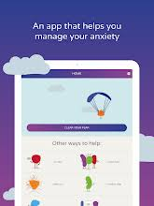

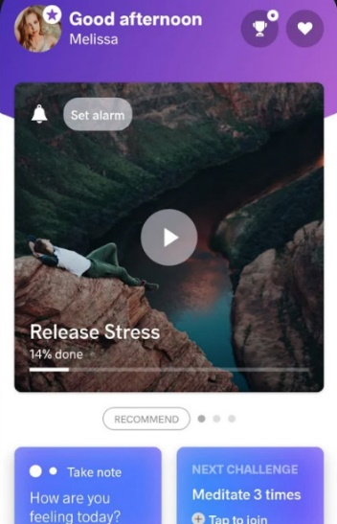

3. Meditopia

Meditopia’s library offers over 1000+ guided meditations on topics including stress, anxiety, acceptance, happiness, motivation, focus and breath. With over 7 million members worldwide, they offer each of these members deep-dive meditations. Even if you don't have your iPhone with you, you can access all of the content from Apple Watch, and start your day off with a daily meditation or one of your favourite practices.

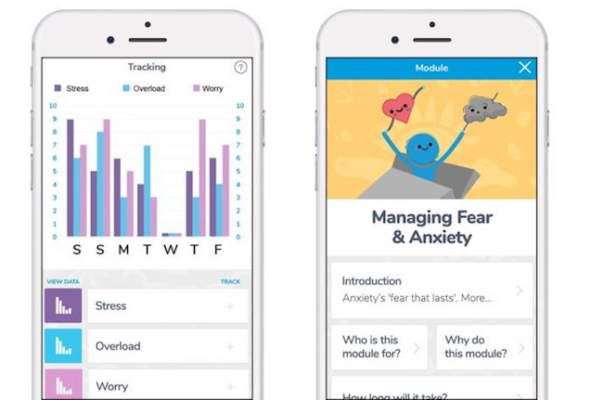
4. My Possible Self

If your mental health is a concern, My Possible Self may be the app for you. Use the 'moments' function to monitor your feelings and recognise any patterns or triggers in your behaviour, and the self-help 'modules' to tackle issues such as stress, anxiety, loss or major life changes.

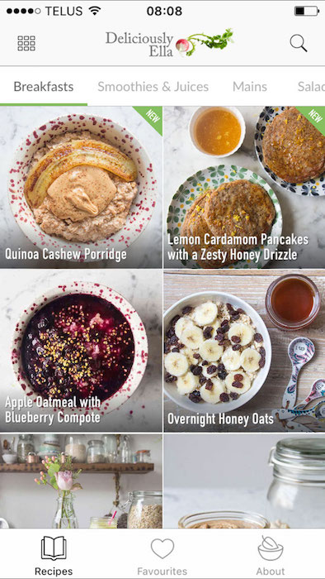
5. Deliciously Ella

A recipe book in your pocket, cult lifestyle blogger Deliciously Ella's popular app brings her delicious plant-based recipes straight to your phone, with nearly 300 nutritious dishes to choose from. Everything is vegan friendly, gluten-free and refined sugar free, so it's ideal whether you're looking for a healthy mid-week meal or considering extending your veganuary pledge…

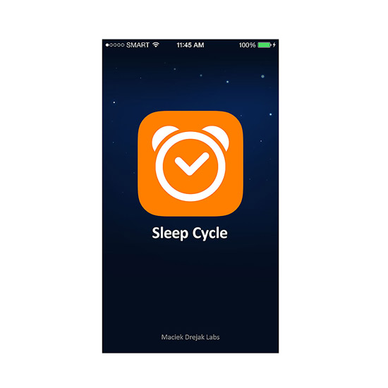

6. Sleep Cycle

Does sleep generally stress you out? Do you feel like you constantly don't get enough of it or, at least, your quality of sleep isn't that great? This app could seriously help. Tracking your sleep cycle throughout the night, based on movement and sound analysis, it works to wake you up when you are at your lightest sleep which means you'll be much less groggy and grumpy rising.

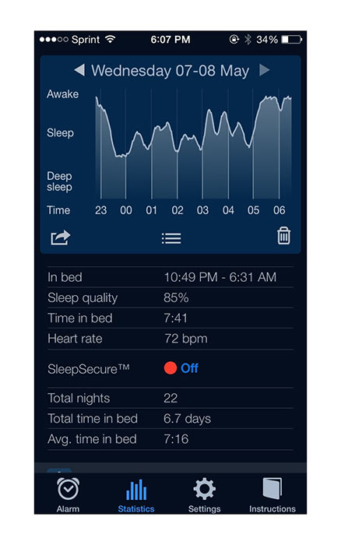

7. Sleep Cycle Alarm Clock

Are you wanting to get more sleep and stop the endless scrolling through Instagram before bed? Sleep Cycle Alarm Clock is an intelligent alarm clock that tracks your sleep patterns and wakes you up in light sleep, helping you to feel more rested and energised.

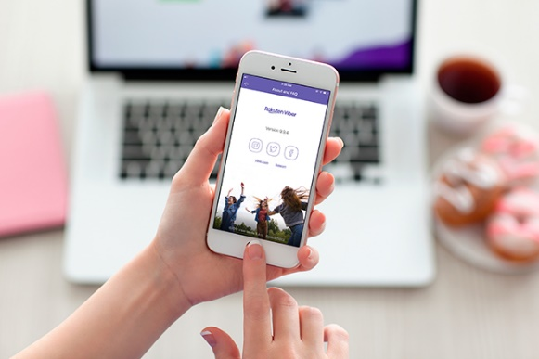
8. Viber

Leading messaging app Viber, connects over 900 million users around the globe and is a digital platform that provides users with access to supportive online communities and groups. Online communities are a great way in which people can hold themselves accountable and seek motivation from likeminded individuals. Group chats can offer support for fitness, cooking and book recommendations.
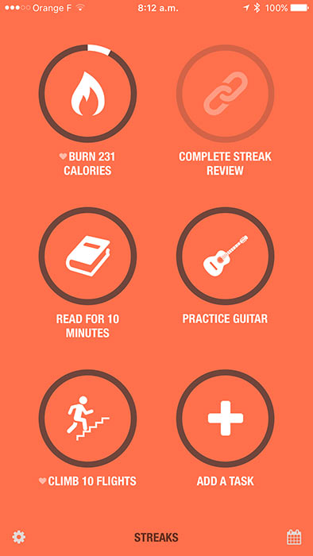
9. Streaks

Streaks is a to-do list that helps you form good habits, and an essential app to hold you accountable to all your goals. The app allows you to track up to twelve tasks you want to complete each day and the goal is to build a streak of consecutive days. Whether it is going for a run or reading a chapter of a book – Streaks can help you keep track of these tasks.

10. The ECG App
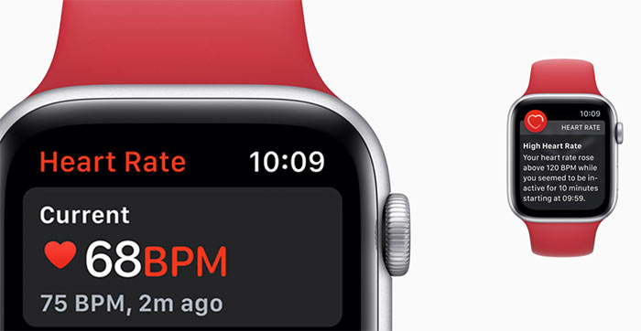
The Apple Watch is capable of generating an ECG similar to a single-lead electrocardiogram. This informative data will be automatically stored in the Health app on your iPhone and can be shared as a PDF with your doctor.

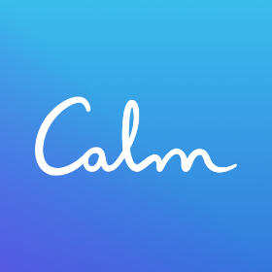
11. Calm
A meditation and relaxation aid. Calm, named the 2017 app of the year by Apple, promises to help users to sleep better, boost their confidence and reduce stress and anxiety levels, all through the help of guided meditations, soothing music and bedtime stories.

