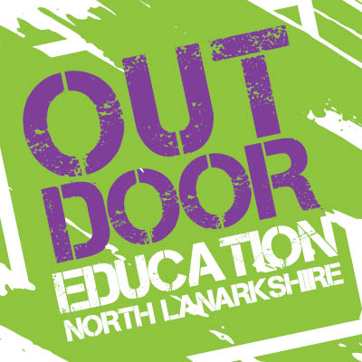Pupil Consent Form

Your child is being offered outdoor education at Palacerigg Country Park and will get the opportunity to take part in various activities such as led cycles, orienteering, archery, bushcraft, team challenges, Palacerigg Games and lots more! We are always adding to the programme and have some new exciting activities being introduced soon! The cost for 5-day experience is £126 and a pro rate price will apply for 3 and 4-day experiences. OUR 4 day experience will cost £105.60 and will occur from Tue 29th Sept – Fri 2nd Oct. The school can subsidise each child by £15.60 bringing the cost down to £90 per child. This does not need to paid in full by 29th September - it can be paid between now until November 2026 – whatever suits you as a family.
All customers must provide a minimum of 1 weeks’ notice on all bookings if you wish to cancel to receive a full refund.

Important Information:

- Pupils are required to bring a packed lunch for lunch time, a snack and drink for morning break. If in receipt of free school meals the school will provide a lunch for pupils.
- No valuable items should come to the park. There is no safe place to store them. Children are prohibited to bring/use mobile phones or children’s smart watches during the program.
- The pupils will be outdoors most of the time at the park so should come dressed appropriately according to the weather – see equipment checklist (Please check weather forecast each day).
- Cycling – If your child is a non-cyclist or not confident, we will work with to increase their confidence throughout the week. We supply the bikes & helmets.
- Transport – Pupils are picked up by a bus at 9am from the school and returned to the school for 3pm.

Kit List (Depending on season)
- Spare socks
- Waterproofs – Jacket & Trousers (We have spares if the pupil does not own these)
- Full change of clothes
- Plenty of water
- Packed Lunch
- Healthy snacks for morning break
- Warm clothing (Gloves, hat, scarf, layers if possible)
- Suncream
- Own helmet if they wish & cycling gloves if they have these
- Change of shoes/wellies (We have spare wellies if pupil does not own these)
- Hand towel
We are delighted to have your school attending the programme and we are looking forward to getting to know your pupils. Can you please fill in the attached consent form and return to the school office before the commencement of the Outdoor Programme.
Please note that no nut products are permitted to be brought to our Sports Camps. While North Lanarkshire Council (NLC) takes every precaution to reduce the risk of exposure, we cannot guarantee that children attending have not recently come into contact with foods containing peanuts or other allergens.
If you have any questions regarding the programme before the visit, please contact me on the details below:
Outdoor Education Team
Email: EFOE@northlan.gov.uk

Consent Form

Full Name of Pupil: ________________________________________
Date of Birth: _____________________________________________
Home Address: ____________________________________________
Post Code: _______
School Name:____________________________________________________

Emergency Contact 1:
Parent/Guardian Name: ______________________________________
Emergency Contact Number: __________________________________
Emergency Contact 2:
Parent/Guardian Name: ______________________________________
Emergency Contact Number: __________________________________

Medical Information:
Does your child have any medical conditions, allergies, or require any medication? If yes, please provide details:
Medical Conditions: _________________________________________
Allergies: _________________________________________________
Medication Details: _________________________________________
Special Dietary Requirements: ________________________________
Doctors / health care centre contact details: _________________________________________________________

Outdoor Activity Permission:
Can your child ride a bicycle? [ ] Yes [ ] No

Sunscreen Permission:
We encourage the use of sunscreen during outdoor activities to protect your child from harmful sun exposure.

Please indicate your preference below:
[ ] I give permission for my child to apply sunscreen during the Outdoor Education Programme.
[ ] I do not give permission for my child to apply sunscreen during the Outdoor Education Programme.

Photo Consent:
We may take photographs or videos during the Outdoor Education Programme to document the learning experiences and for promotional purposes.
Please select your consent preference:
[ ] I give consent for my child's photo or video to be taken and used for educational and promotional purposes related to the Outdoor Education Programme.
[ ] I do not give consent for my child's photo or video to be taken and used for any purposes related to the Outdoor Education Programme.

As the Parent/Guardian, I agree that I am happy for my child to attend the Outdoor Education Programme at Palacerigg Park and part take in all the activities delivered. In the event that emergency first aid is to be administered to my child, I agree that I am happy for this to happen.

Print Name: ……………………………………

Signed …………………………………………. Date…..………………………………..

