Enabling Guided Access on iPads
Guided Access is a useful feature available on Apple devices, such as iPhones and iPads, that can help parents and carers manage a child’s device use while they are playing games or using an app. Guided Access allows you to keep a child within a single app, preventing them from accidentally exiting and accessing other content on the device. You can also restrict access to certain areas of the touchscreen – for example, preventing access to in-game stores where a child may be able to make purchases or buy add-ons. This can help create a safer, more controlled experience and give parents and carers greater peace of mind while children play.

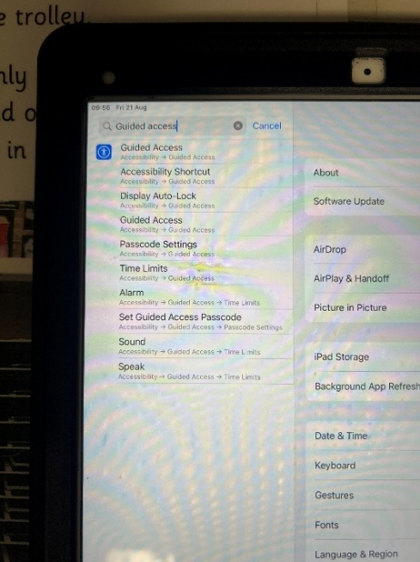
- Before using Guided Access, you first need to make sure the feature is enabled. Open Settings and search for ‘Guided Access’ using the search bar at the top of the screen. Alternatively, you can find it by following:
Settings -- Accessibility -- Guided Access
Open this section and turn on the Guided Access toggle. The toggle should turn green when it is enabled..

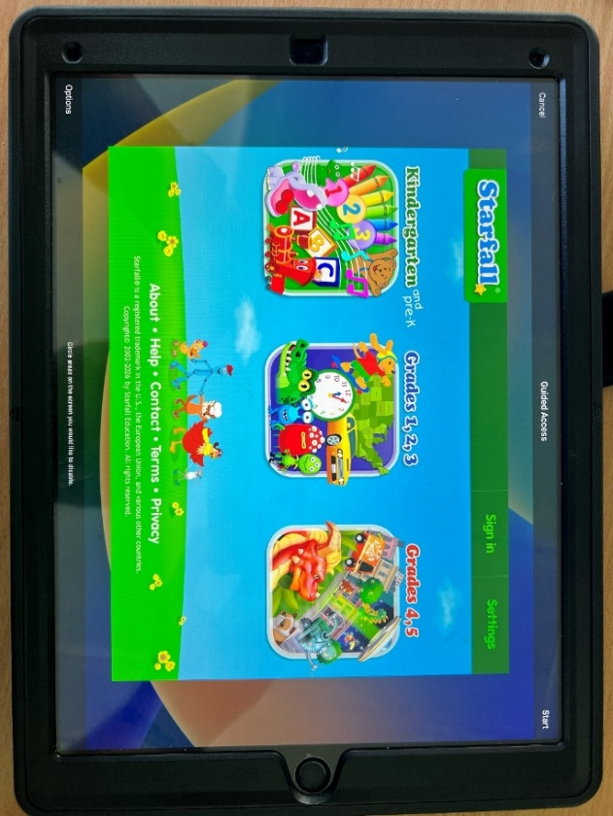
- Once Guided Access has been enabled, open the app you would like your child to use.
Devices with a Home button: Triple-click the Home button.
Devices without a Home button: Triple-click the Side button (the lock button).
The Guided Access border screen will then appear.

To prevent your child from exiting a specific app, follow Step 3 or Step 4, depending on the type of device you have.
To disable access to certain areas of the screen, such as in-app stores or content that may not be suitable for your child, follow Step 5.

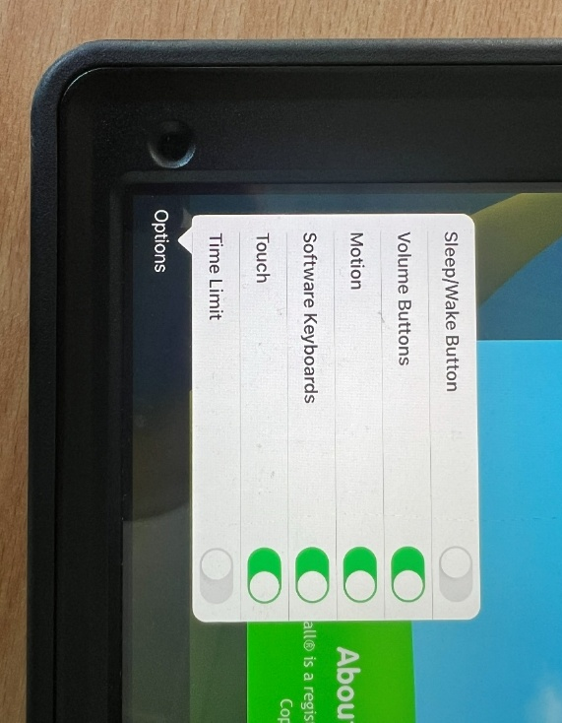
If your device is an older model and has a home button, follow step 3.
3. If your device is an older model with a Home button, select ‘Options’ at the bottom of the screen. Ensure that Sleep/Wake Button is toggled off (not green) to prevent your child from exiting Guided Access using the device buttons. You can also adjust any other settings as appropriate. We recommend keeping the Volume Buttons enabled so that the volume can be adjusted during gameplay if needed. Once you are happy with the settings, select ‘Start’ in the top-right corner of the screen. Guided Access will then begin.

If your device is a newer model and has no home button, follow step 4.
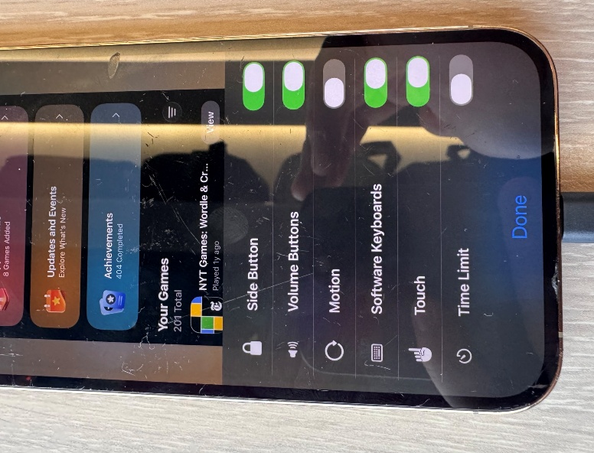
4. If your device is a newer model without a Home button, select ‘Session Settings’ at the bottom of the screen. Ensure ‘Motion’ is toggled off (not green) to prevent your child from swiping out of the app and make any other changes you deem appropriate. We recommend keeping the Volume Buttons enabled so that the volume can be adjusted during gameplay if needed. Once you are happy with the settings, select ‘Start’ in the top-right corner of the screen. Guided Access will then begin.

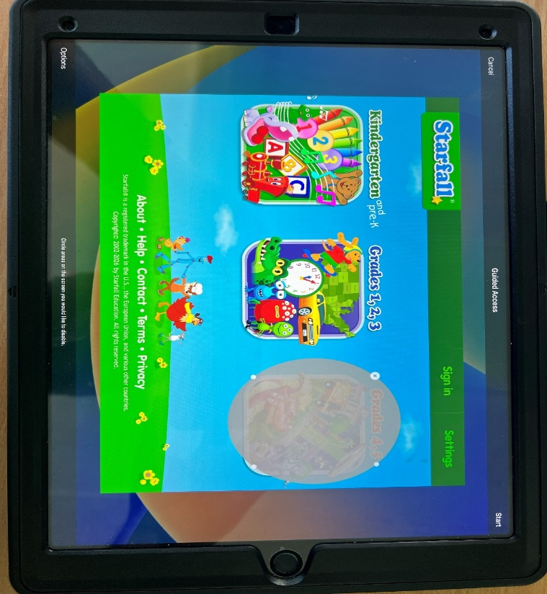
- Guided Access also allows you to
prevent access to specific parts of the screen. To do this, use your finger to draw a circle around the area you want to disable. A greyed-out area will appear over that section, indicating that it can no longer be accessed. This can be particularly useful for blocking access to features such as in-app stores or other areas you do not want your child to use. Once you have selected the areas you want to disable, press ‘Start’ in the top-right corner of the screen. Guided Access will now begin.

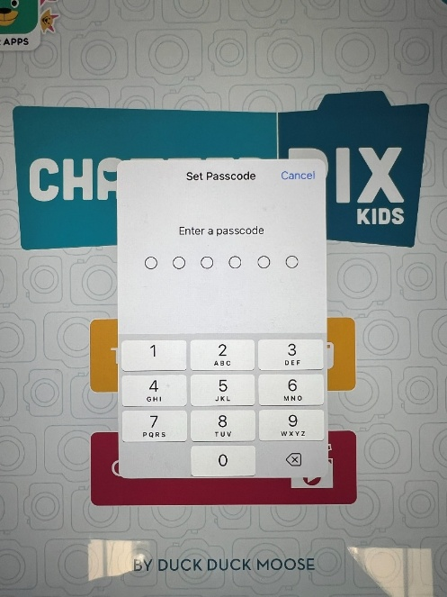
- You may be prompted to create a 4-digit Guided Access passcode. We recommend that you:
- Do not share this passcode with your child.
- Choose a passcode that is different from
your usual device passcode, particularly if your child already knows it.

To exit Guided Access, triple-click the Home button or Side button, depending on your device. You will then be asked to enter your Guided Access passcode. Once entered, you can end the Guided Access session and return to normal use of the device.

