How to upload completed work to an assignment
- Click on the ‘assignments’ icon on the left hand side.
- Click ‘view assignment’ on the assignment you’d like to add work to
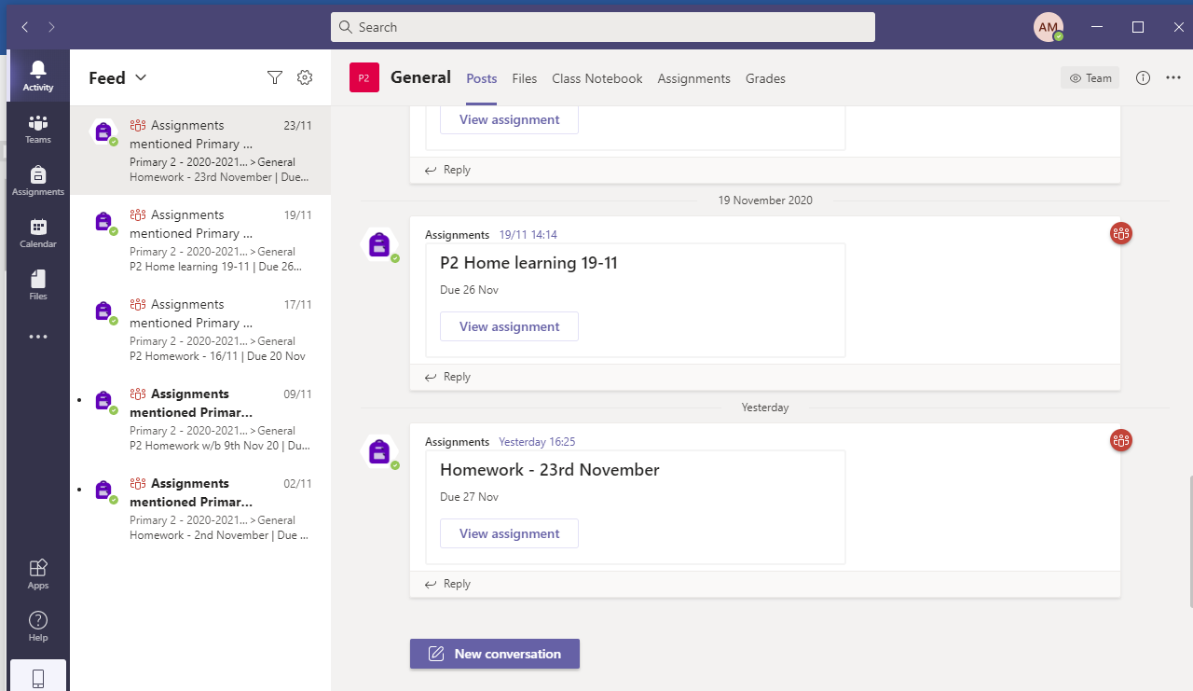

- Scroll to bottom and look for ‘My Work’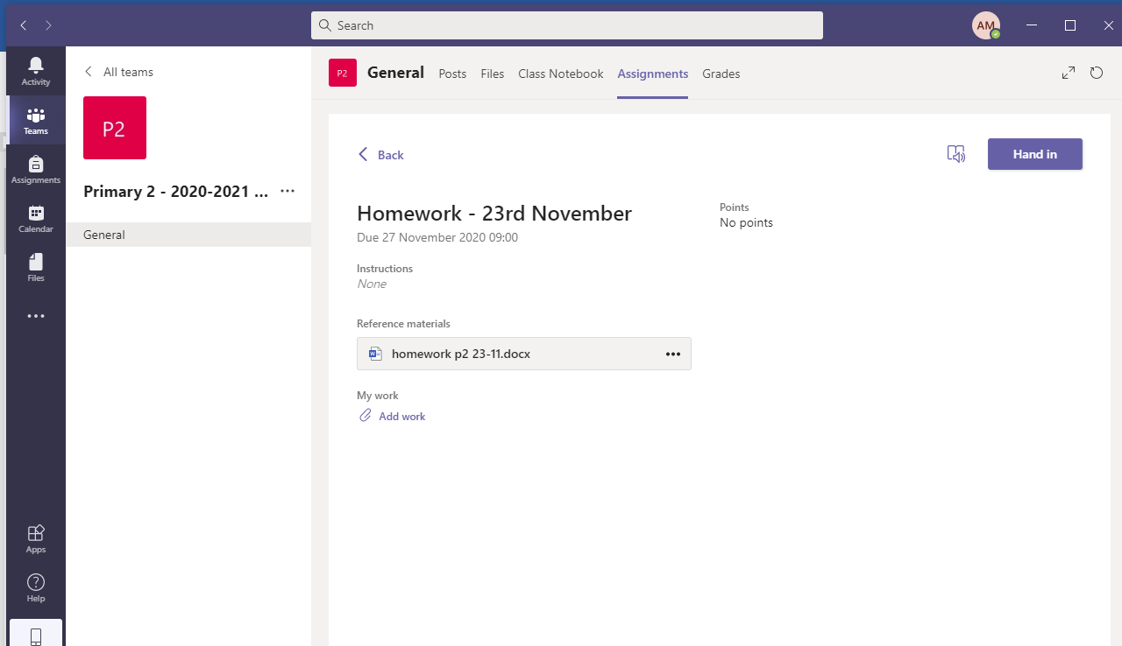

Select: 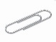Add work
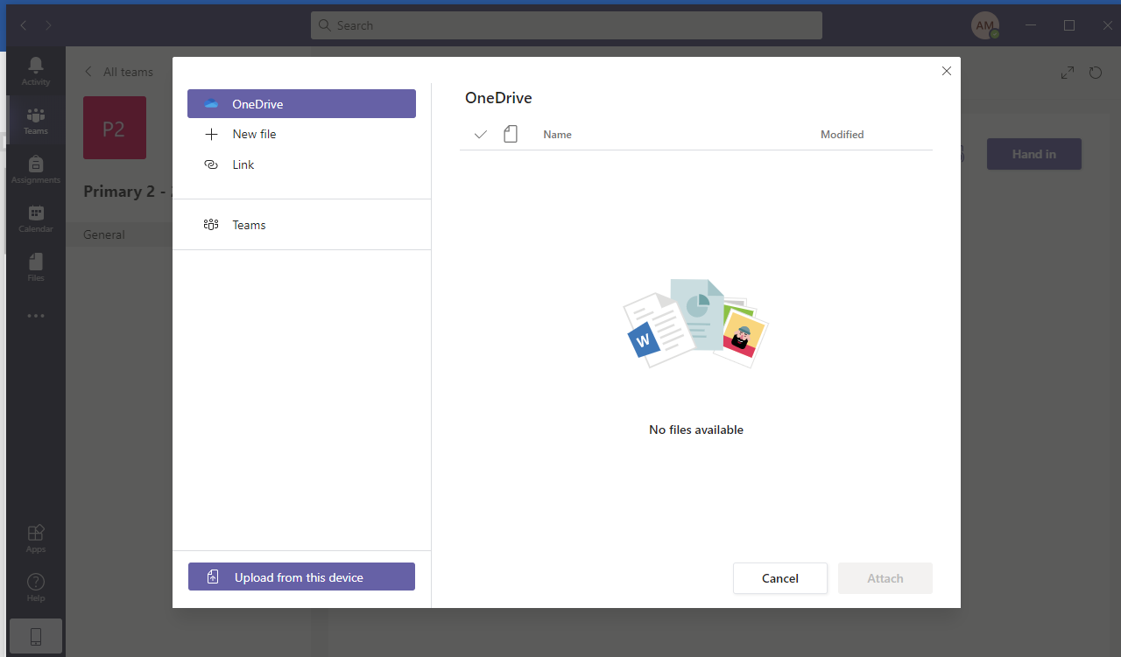
Select: Upload from this device
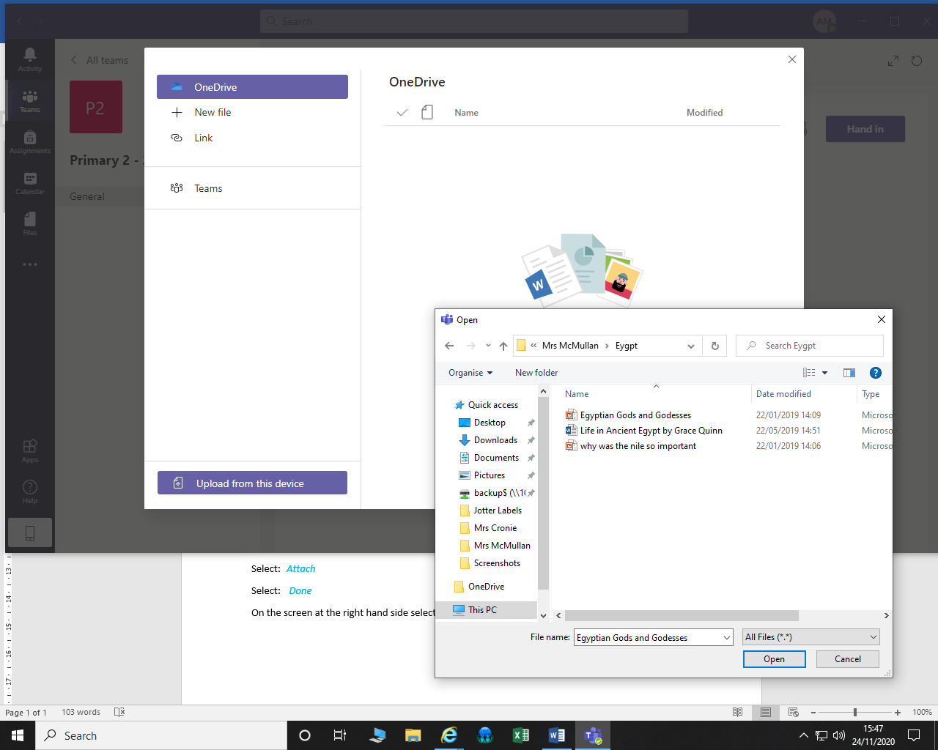
Choose the file(s) or photograph(s) you wish to upload.
Click: Open
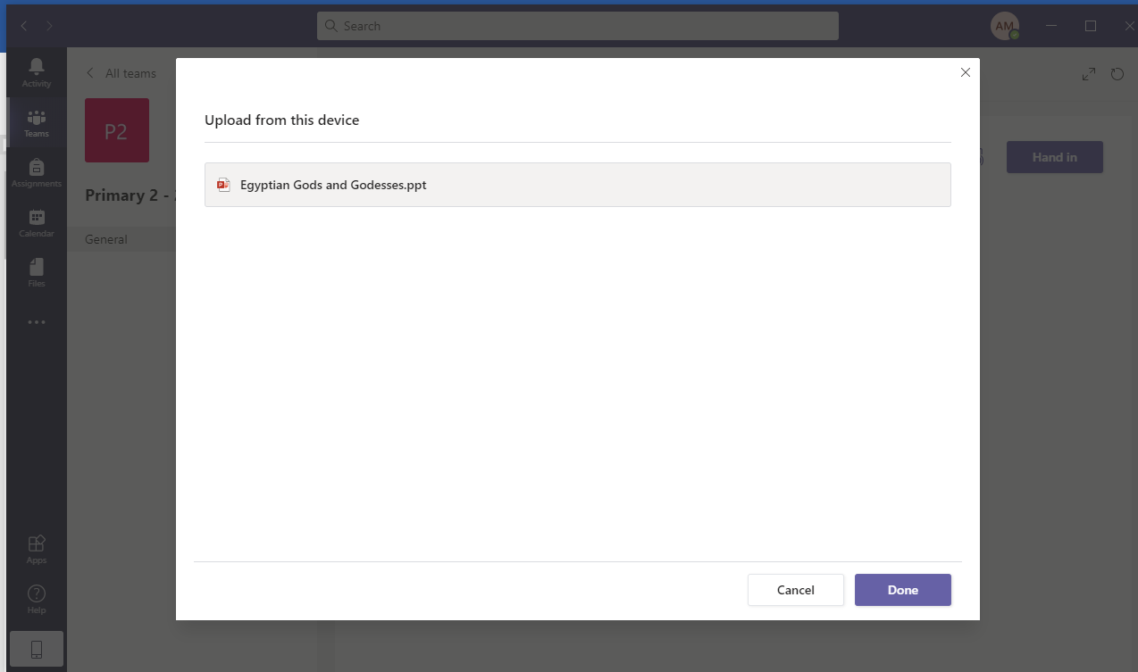
Wait for the green line to travel across the screen
Select: Attach
Select: Done

On the screen at the right hand side select: Hand In
