Reading
Reading materials can be accessed at:
www.oxfordowl.co.uk
Click on ‘my class login’ and enter the following:
Username: sthelensp3
Password: sthelens
Click on ‘my bookshelf’ and type in the title of your book in the ‘search bar’. Book titles are listed below.
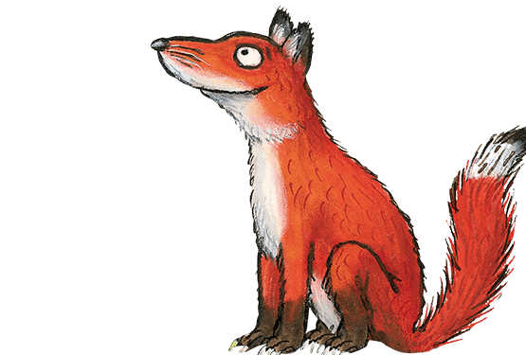

Foxes – A Life in the Sky

Gruffalos – Your Body, Inside and Out
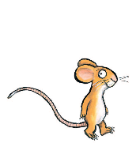

Mice – Escape of the Giant Chicken
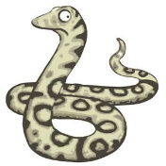

Snakes – A Pony for a Day
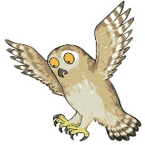

Owls – Helter-Skelter

You can listen to the audio version of the story and try reading it aloud. Once you have finished reading, try the activities that are at the top of the page.

Handwriting
I have attached handwriting activity sheets. There are 8 sheets in total, please complete the last two sheets on ‘corner letters’. If you can, try joining up your letters like we have been doing in class. If you can’t print the sheets, copy the letters/words onto paper/whiteboard to practise.
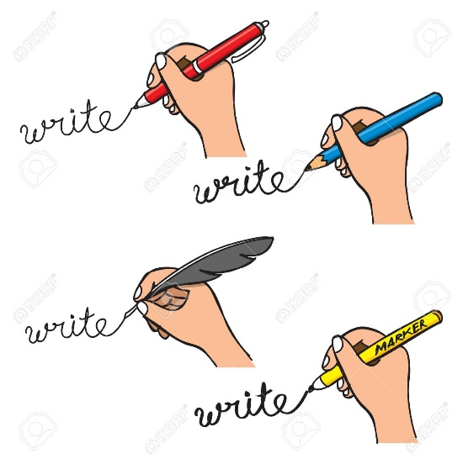

Learning Intention:
We are learning to form our letters correctly.

Success Criteria:
I can:
- Form all corner letters correctly.
- Join letters correctly.
- Write words clearly and legibly.
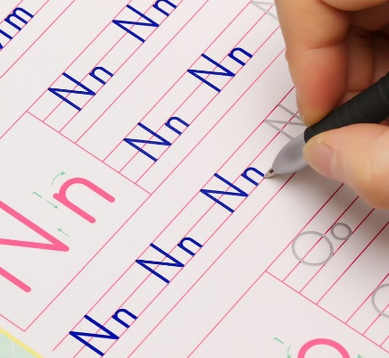

Maths
Circles | Squares | Triangles
Mental Maths:  2x6=  10+6=  12-8=  5x5=  10x8=  20-13=  15-9=  8+8=  2x0=  2x9= | Mental Maths:  10x6=  5x9=  24+24=  50-20=  3x7=  34+17=  43-21=  3x3=  10x0=  12+42= | Mental Maths:  3x4=  5x6=  23+67=  98=36=  2x10=  45+45=  26+25=  73-43=  89-54=  4x9=
Use daily 10 to build your confidence in mental maths.

https://www.topmarks.co.uk/maths-games/daily10
Can you create your own addition, subtraction and multiplication questions? These could be the same way as above or you could make word problems.

Get an adult to test you on addition, subtraction and multiplication. You could even try doing them differently e.g. outside using chalk, using leaves or using sticks!
Make sure you challenge yourself, for example, if you have been learning the 6 times table then make sure you get asked questions on this!

Good luck

*Self-assess your learning. Put a red, amber or green at the top of your worksheet to let me know how you found it.
- I found this work too difficult and I didn’t really understand it.
- I managed this work but found some of it tricky.
- I managed to complete my work independently.

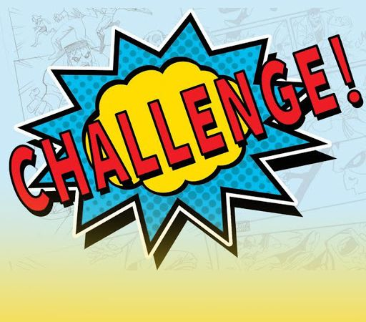
Primary 2/3 Challenge: Fitness Fun in the Sun

Each week in June Primary 2 and 3 children will be given a new challenge which will be announced on a Monday.
You must post a picture or video of yourself doing your challenge on your Class Microsoft Teams page by Friday evening.
The prize: A digital certificate for you to keep and display in your home.
We will also be awarding certificates to the class who has the most participants.
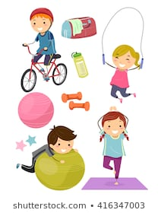

Week 1: Miss Harper’s Challenge
Week 2: Miss Williamson’s Challenge
Week 3: Mrs Hasselstrom’s Challenge
Week 4: The ULTIMATE Challenge
Who is up for the CHALLENGE?

This week is Mrs Hasselstrøm’s Challenge:

My challenge is the Step and Selfie Challenge

- Choose one day this week to go out a walk with your family and track your steps while you do it. You could do this on an iphone, watch or device.
- Screen shot the amount of steps walked at the end and post this on your class Microsoft teams page along with a selfie of you out your walk!

- Happy walking and selfie taking!

Remember you must upload your photo to your Microsoft Team by Friday.

Have fun and good luck, Mrs Hasselstrøm

