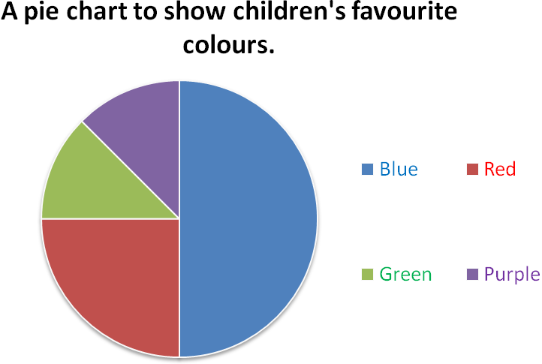
Altogether 40 children were asked what their favourite colour is.

How many children chose blue?

How many children chose red?

How many children chose green?

How many children chose purple?
Which colour is the most popular?
Which colours are the least popular?

Challenge Tasks x 2:
Imagine now that 80 children were asked but the pie chart stayed exactly the same. How many children chose each colour this time?

Blue =

Red =

Green =

Purple =
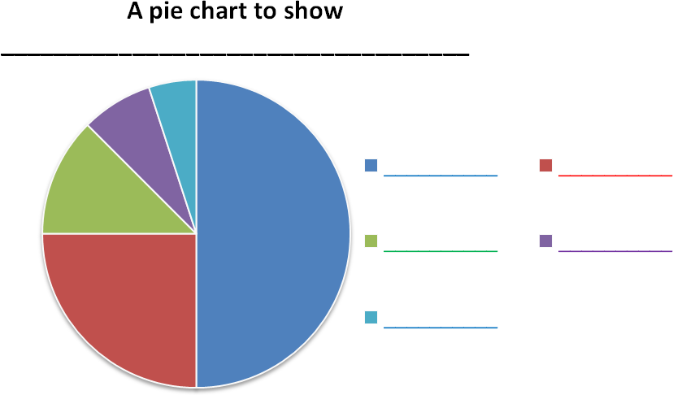
Altogether ____ children were asked _________________________________.

Using the pie chart above create your own set of data and questions about the data. You can choose how many children were asked.
Don’t forget to add the chart title and data labels.
You must be able to answer your own questions (but don’t write them on the sheet – keep them to yourself for now).

