**Primary 4b – Home Learning Tasks**

**Thursday 11th June 2020**

[](https://www.google.co.uk/url?sa=i&url=https%3A%2F%2Fclipartstation.com%2Freading-clipart-png-1%2F&psig=AOvVaw0Ty9i8k4rZ8VwCFEaONonO&ust=1585138177066000&source=images&cd=vfe&ved=0CAIQjRxqFwoTCJj494GKs-gCFQAAAAAdAAAAABAE)

**DEAR Time**

Continue to take some time to Drop Everything and Read!

Find a quiet place in your house, take a book of your choice and spend at least ten minutes having some quiet reading time ☺

Try to do this every day of the week!

**Reading**

Reading materials can be accessed at:

[www.oxfordowl.co.uk](http://www.oxfordowl.co.uk)

Click on the ‘My Class Login’ and use these details:

Username: sthelensp4b

Password: StHelensP4b

Authors Group – ‘Comic Capers’

<https://www.oxfordowl.co.uk/api/interactives/30571.html>

Editors Group – ‘Peter and the Wolf’

<https://www.oxfordowl.co.uk/api/interactives/30565.html>

Illustrators Group – ‘Double Cross’

<https://www.oxfordowl.co.uk/api/interactives/30569.html>

Publishers Group – ‘Pirate Poems’

<https://www.oxfordowl.co.uk/api/digital_books/1351.html>

Read over the eBook with an adult and on your own at home. This should be repeated throughout the week. Complete the eBook tasks within the front or back cover of the book.

Additional tasks – Summary

L.I – To create a summary of the main ideas.

Success Criteria

To use my own words as much as possible

To check back over my writing to ensure it makes sense.

Text Detective

L.I – To create a list of verbs, nouns and adjectives in my book.

Success Criteria

* To remember a noun is ‘naming’ word, a verb is a ‘doing’ word and an adjective is a ‘describing’ word.

Writing – My Super Power

L.I - To create a narrative story using a video as stimulus.

Watch the following video clip on YouTube –

<https://www.youtube.com/watch?v=JRfuAukYTKg>

I love videos like this because, as well as being a great song, the video tells a story throughout. Using the video as stimulus, using the boy’s story or creating your own, we are going to create a story imagining that you have a super power of your own.

What is your superpower? How did you get it? How have you used it to your advantage? Does anyone else know about it? Do you wish you didn’t have a superpower?

Remember to give your story a starter, a main part and an ending. Try to give as much detail as possible to make it interesting for your reader.

Success Criteria

* Use of paragraphs throughout
* Use of appropriate punctuation throughout – full stops, capital letters, and speech marks etc.
* Include reasons for character thoughts/feelings where possible.

Numeracy Tasks



SUMDOG North Lanarkshire Contest!

Friday 5th June – 11th June.

Let’s win this one P4b!

For our numeracy tasks, please continue to work through the revision booklet that was handed out with the tasks on Tuesday.

Japan Topic

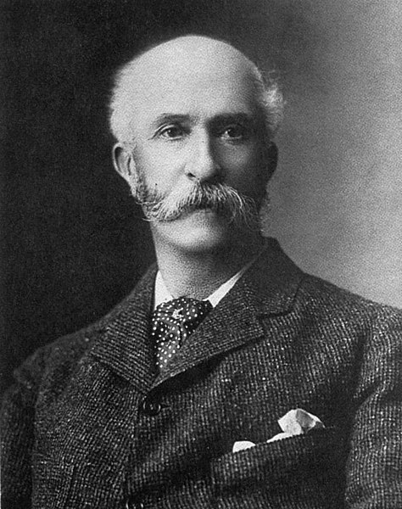For our topic work today, we are going to be finding out about a significant Scottish individual, who made his life and career in Japan. I have included a PowerPoint to tell you all about the life of Thomas Blake Glover and why he was so important. I have also attached a fact file for you to complete afterwards.

L.I – To explain who Thomas Glover was and why he was a significant individual.

Success Criteria

* To use the information from the PowerPoint to help me complete my task.