Reading
Reading materials can be accessed at:
www.oxfordowl.co.uk
Click on ‘my class login’ and enter the following:
Username: sthelensp3
Password: sthelens
Click on ‘my bookshelf’ and type in the title of your book in the ‘search bar’. Book titles are listed below.
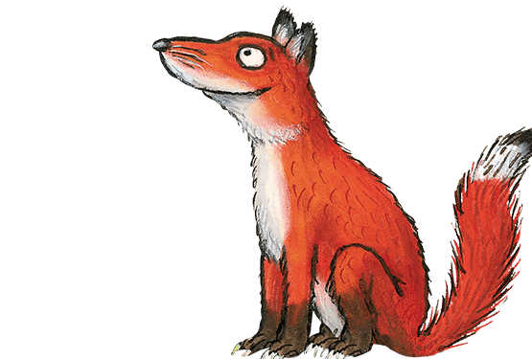

Foxes – Tom Thumb and the Football Team
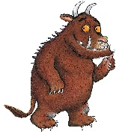

Gruffalos – Rabbits, Hats and Secrets
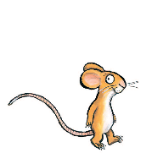

Mice – Dinosaur Safari
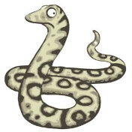

Snakes – Perfect Pets
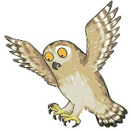

Owls – It’s Too Hot

You can listen to the audio version of the story and try reading it aloud. Once you have finished reading, try the activities that are at the top of the page.

Text Detective
Using your reading book, find as many 3, 4, 5, and more than 5 letter words as you can from your reading book. I have attached a template that you may want to use, but you could also create your own on paper.

Learning Intention
We are learning to group words correctly by the number of letters using my reading book.
Success Criteria:
- Count the number of letters in each word.
- Copy the word from my book correctly (make sure you check the spelling).
- Write the word in the correct column.

Text Detective
3 letter words | 4 letter words | 5 letter words | More than 5 letter words

Grammar
You are going to add the correct punctuation to the sentences in the worksheet attached.
Remember:
- Capital letter at the beginning of a sentence and for proper nouns.
- Full stop at the end of a sentence.
- Comma (,) to separate a list, for example, I went to the shops to buy bread, milk and juice.
- Question mark (?) if you are asking a question.
- Exclamation mark (!) if someone is shouting, angry, surprised or excited.

I have attached a punctuation worksheet and there is 3 worksheets on the one document. At the bottom of the page there is 1, 2 or 3 stars.
1 star = mild
2 stars = spicy
3 stars = hot
You decide which worksheet is best for you to complete. Remember to challenge yourself where you can!
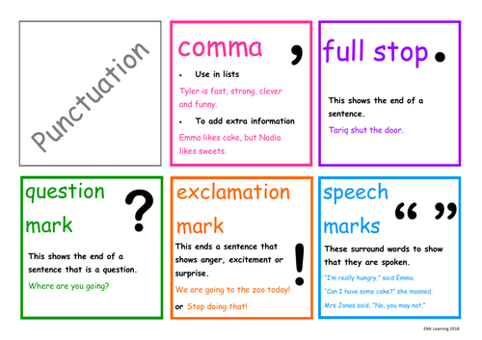
If you begin and it is too easy, move onto the next sheet or if you begin and it’s too difficult, change sheet. It is okay to swap worksheets without completing, if required!

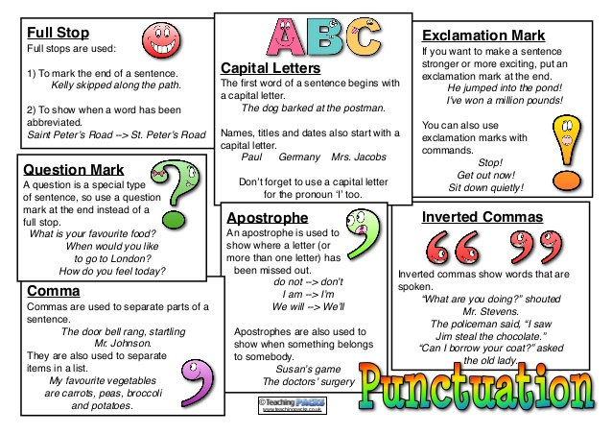
Maths
Circles | Squares | Triangles
Use daily 10 to build your confidence in mental maths.

https://www.topmarks.co.uk/maths-games/daily10

Practise counting forwards and backwards starting from any number in the sequence.  Practise 2, 5 and 10 times tables. | Practise counting forwards and backwards starting from any number in the sequence.  Practise 2, 3, 5 and 10 times tables. | Practise counting forwards and backwards starting from any number in the sequence.  Practise 2, 3, 4, 5 and 10 times tables.
I have attached a worksheet on Time. It is looking at o’clock. Remember, that is when the minute hand (the big hand) is at the 12.  Please complete the second worksheet. | I have attached a worksheet on Time. It is looking at o’clock and half past. Remember, it is o’clock the minute hand (the big hand) is at the 12. When it is half past, the minute hand (the big hand) is at the 6.  Please complete the second worksheet. | I have attached a worksheet on Time. It is looking at o’clock and half past. Remember, it is o’clock the minute hand (the big hand) is at the 12. When it is half past, the minute hand (the big hand) is at the 6. It is quarter past when the minute hand is at 3 and it is quarter to when the minute hand is at 9.  Please complete the second worksheet.
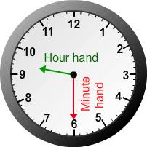
Here are some time games you could play to practise.
https://www.splashlearn.com/time-games
*Self-assess your learning. Put a red, amber or green at the top of your worksheet to let me know how you found it.
- I found this work too difficult and I didn’t really understand it.
- I managed this work but found some of it tricky.
- I managed to complete my work independently.

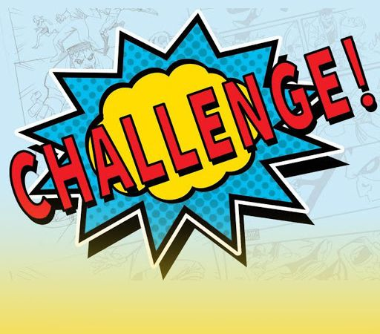
Primary 2/3 Challenge: Fitness Fun in the Sun

Each week in June Primary 2 and 3 children will be given a new challenge which will be announced on a Monday.
You must post a picture or video of yourself doing your challenge on your Class Microsoft Teams page by Friday evening.
The prize: A digital certificate for you to keep and display in your home.
We will also be awarding certificates to the class who has the most participants.
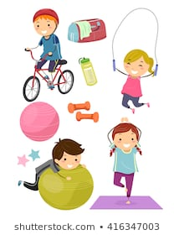

Week 1: Miss Harper’s Challenge
Week 2: Miss Williamson’s Challenge
Week 3: Mrs Hasselstrom’s Challenge
Week 4: The ULTIMATE Challenge
Who is up for the CHALLENGE?

This week is Miss Williamson’s Challenge:

My challenge is the cha cha slide plank edition.

This video clip will walk you through it:

https://www.youtube.com/watch?v=x_YFkVSp34s

It’s not for the faint hearted and will definitely get your heart racing.

Remember you must upload your photo of video to your Microsoft Team by Friday.

It’s a tricky one… you might need to practise it a few times…

Have fun and good luck, Miss Williamson xo

Well done for taking part in my challenge last week and being the WINNERS!!
Can we be the winners again Primary 3? Let’s do this!

