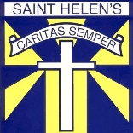 Primary 6/Miss O’Toole – Home Learning 11th of June

Every Tuesday and Thursday (before 10am) I will be posting home learning tasks for you to work through. New spelling words will be posted every Tuesday.
Oxford Owl Login
Username:sthelensp6
Password: school

Reading Tasks
Red Group | Blue Group | Green Group | Orange Group
LI: To express my thoughts and opinions of a given chapter.  TASK  Read chapters 11 and 12 of ‘Storm Chasers’ (Oxford Owl – link below). Choose one chapter to write about and complete the CSI task.  Success Criteria:  Identify a colour, symbol and image to represent chapter 11 or 12.  Create sentences for each that explains why. | LI: To identify the main ideas of a given chapter  TASK  Read chapters 11 and 12 of ‘Black Beauty’  (Oxford Owl – link below). Note the main ideas of the chapter.  Success Criteria:  Note each of the main ideas of the chapters. | LI: To state what the author infers.  TASK  Access and read ‘Escape of the Giant Chicken’ (Oxford Owl – link below/login details above). Complete the after reading questions on pg 25.  Success Criteria:  To use evidence from the text.  State what the author means.  Write in full sentences. | LI: To use evidence from the text.  TASK  Access ‘Our Class Tiger’ (Oxford Owl – link below). Find out why tigers have spots on the backs of their ears (pg 21).  Success Criteria:  Use evidence from the title, to find out factual information.  Write in full sentences.
Link to Clips:
Red Group https://www.oxfordowl.co.uk/api/digital_books/1386.html
Blue Group https://www.oxfordowl.co.uk/api/digital_books/1336.html
Green Group https://www.oxfordowl.co.uk/api/digital_books/1254.html
Orange Group https://www.oxfordowl.co.uk/api/interactives/12950.html

Spelling Tasks
LI: To spell my weekly words correctly.
Spelling words can be found on Tuesday’s home learning grid.

Task – Spelling Check-Up
Ask an adult to read out your spelling words whilst you write them down for a ‘mini check-up’ (just like we do on Fridays in class). This will give you an idea of the words that you may need to practise more.

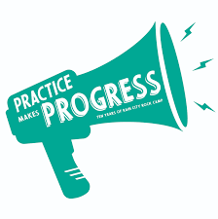

Writing Task – Fairy Tale Continuation
LI: To finalise my own fairy tale story.
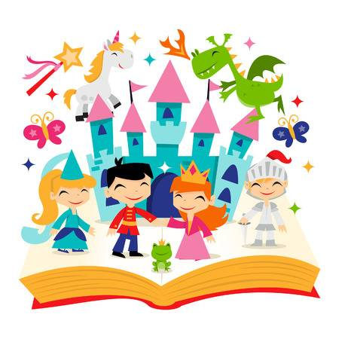
This week, your task is to begin writing the next part of your fairy tale.

Your task, is to create the middle and ending of your story. This should be around 200 words. You can write more if you wish!
- Begin to think about your ‘problem’– Here, you should discuss the main event that takes place. Remember to be specific.

- Think about your solution – How is your problem solved? Do the ‘good’ characters help to solve this?

- Bringing your story to an end – Begin to build up to your ending. Think about our discussions in class about excellent endings. Try to build suspense. Typical fairy tale stories normally have a happy ending. Is this something you may consider too?
Success Criteria:
I will be successful if I…
Present a problem and a solution.
Use descriptive language.
Bring my fairy tale to an appropriate conclusion.
Ensure my layout is typical of a traditional fairy tale (EG: Includes illustrations).

- Think about your layout – Remember to ensure that your layout is that of a typical fairy tale. Think about your sentence structure and the use of illustrations.

Numeracy Tasks
1) Mental Starter: Complete the mixed times table challenge at https://www.topmarks.co.uk/maths-games/daily10
2) Number Talks: Try to aim to solve your chosen question within 5 minutes (use a timer). If you manage to solve the problem with time to spare, try to use a different Number Talks strategy like we do in class. See the grid below to recap your strategies.
Hot | 125 x 8 =
Spicy | 45 x 12 =
Mild | 8 x 9 =
Number Talks Strategy Examples – Multiplication
You may recognise some of these sums from our Maths wall. I have created this grid to recap your memory of the different multiplication strategies we have learned in class.
Friendly Numbers  9 x 15 =  10 x 15 = 150  150 – 15 = 135.  We multiply 15 by 10 as it is a friendly number. We remember to ‘UNDO’ our change by taking 15 away from our answer. | Repeated Addition  6 x 15 =  15 + 15 + 15 + 15 + 15 + 15 =  15 + 15 = 30  30 + 15 = 45  45 + 15 = 60  60 + 15 = 75  75 + 15 = 90 | Partial Products  6 x 125 =  6 x (100 + 20 + 5) =  6 x 100 = 600  6 x 20 = 120  6 x 5 = 30  600 + 120 + 30 = 750
Doubling and Halving  24 x 8 =  x2 ÷2  48 x 4 =  x2 ÷2  96 x 2 = 192 |  | Final Number Talks Hints  - Choose the strategy you feel most confident in to begin with.  - Afterwards, you can begin to think about the strategy that is most efficient for your given sum. (This is a top goal of ours in class).
Red Group | Blue Group | Green Group | Orange Group
LI: To name the different triangles.  TASK  Complete the ‘Types of Triangles’ worksheet. The information on the left hand side will help you to complete this. The video clip below will provide further support if needed.  Success Criteria:  Draw given angles.  Use knowledge of angles to create accurate definitions. | LI: To order given angles.  TASK  Complete Q1-8 in the ‘Ordering Angles’ worksheet. Here you will be required to order angles from smallest to largest.  Success Criteria:  Order given angles from smallest to largest. | LI: To use whole, half and quarter turns.  TASK  Access the directions Power Point. Complete the green worksheet. Rotate the arrows accordingly.  Success Criteria:  Rotate the arrows accordingly.  Follow the given directions such as left, right, clockwise, anti-clockwise, half turn and quarter turn.  . | LI: To give appropriate directions.  TASK  Access the directions Power Point. Complete the orange ‘Directions in the City’ task. Here, you will be required to use appropriate language to direct others.  Success Criteria:  Create directions.  Use language such as left, right, clockwise and anti-clockwise.
3) Main Tasks:

Red Clip:
https://www.bbc.co.uk/bitesize/topics/zvmxsbk/articles/zggsfrd
Green and Orange Clips: https://www.bbc.co.uk/bitesize/topics/z2grd2p/articles/zwv6b82

IDL – Website Creation Continuation
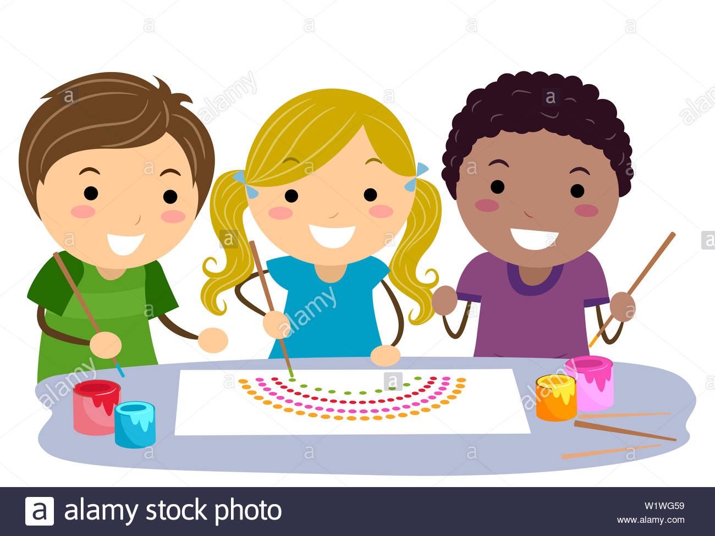
Designing a Website
LI: To create a logo for your website.
As part of our Scottish Inventors topic, we have been learning about many different inventions. Like the telephone, the internet has played a huge part in connecting the world. Your task today is to begin designing your own website logo.

A great logo needs to be instantly recognisable, sum up the whole website and communicate the website’s message using a well-designed image and lettering arrangement.

Experiment with different shapes, colours and ideas before deciding on your final design. Here are some examples of famous logos. Note their simplicity.

Once you have created your logo, explain your final design. Write two/three sentences to explain why you chose to create your logo in this way. I can’t wait to see all of your fantastic masterpieces! – Miss O’T

