Silly Sentences  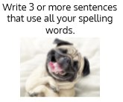 | Word Search  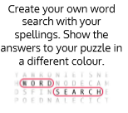 | Write a Story, Poem or Song  Write a short story, poem or song using all your spelling words. Underline the words you used.
Picture Word  Draw a picture and hide your spelling words in the picture. | Rhyming Words  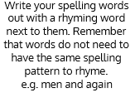 | Train Words  Write the entire list end-to-end as one long word. Write each new word in a different colour. e.g.​ train​back​stop
Questions and Answers  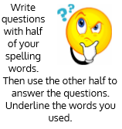 | Just for a laugh  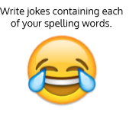 | Antonym  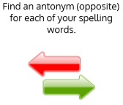
Crossed Words  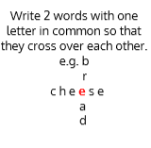 | Words Without Vowels  Write all of your words replacing vowels with a line. Go back and see if you can fill in the vowels. e.g. q--st--n = question | Rainbow Words  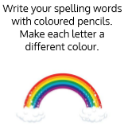
Word Parts  Write your words. Then use a coloured pencil to divide the words into syllables. | Definitions  Explain in your own words what each word means. If you are not sure check in the dictionary and then explain using your own words. | Spelling Strategies  Choose a strategy that suits each word best e.g. syllabification, diacritical marking, mnemonics, compound words or words within words.

