Acute angles are less than/more than 90°.
Acute
Key
Obtuse angles are less than/more than 90°, but less than/more than 180°.
Watch the video link to recap your knowledge of acute, right and obtuse angles.
Estimate the type of each angle below. Use the colour key.
Obtuse

Right angle

- 2. 3.

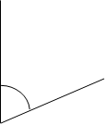
4. 5. 6.

