[](https://www.google.co.uk/url?sa=i&url=http%3A%2F%2Fwww.kitmykid.co.uk%2FSt-Helens-Cumbernauld%2F&psig=AOvVaw3ZkgHlqSaISiO3_QI8FvE4&ust=1585218082517000&source=images&cd=vfe&ved=0CAIQjRxqFwoTCMD219eztegCFQAAAAAdAAAAABAD) **Primary 6/Miss O’Toole – Home Learning 9th of June** [](https://www.google.co.uk/url?sa=i&url=http%3A%2F%2Fwww.kitmykid.co.uk%2FSt-Helens-Cumbernauld%2F&psig=AOvVaw3ZkgHlqSaISiO3_QI8FvE4&ust=1585218082517000&source=images&cd=vfe&ved=0CAIQjRxqFwoTCMD219eztegCFQAAAAAdAAAAABAD)

*Every Tuesday and Thursday (before 10am) I will be posting home learning tasks for you to work through. New spelling words will be posted every* ***Tuesday****.*

**Spelling Tasks**

|  |  |  |
| --- | --- | --- |
| **Red Group** | **Blue Group** | **Green Group** |
| ***LI: To create a paragraph using my spelling words.***  **Prefix Set 4 ‘sub’**  submit  subdue  subway  subject  subside  subtotal  subtract  subconscious  submerge  submission  **TASK**  Create a paragraph using your prefix words. . When selecting your words, think about those that link together well.  **Success Criteria:**  [Image result for star emoji](https://www.google.co.uk/url?sa=i&url=https%3A%2F%2Fwww.iemoji.com%2Fview%2Femoji%2F45%2Fanimals-nature%2Fglowing-star&psig=AOvVaw06GYxWwJ3AvNliwBAuGC65&ust=1585218982355000&source=images&cd=vfe&ved=0CAIQjRxqFwoTCLDI0YS3tegCFQAAAAAdAAAAABAD)*Create a paragraph which includes at least 4 prefix words.*  [Image result for star emoji](https://www.google.co.uk/url?sa=i&url=https%3A%2F%2Fwww.iemoji.com%2Fview%2Femoji%2F45%2Fanimals-nature%2Fglowing-star&psig=AOvVaw06GYxWwJ3AvNliwBAuGC65&ust=1585218982355000&source=images&cd=vfe&ved=0CAIQjRxqFwoTCLDI0YS3tegCFQAAAAAdAAAAABAD) *Use figurative language to add further description.* | ***LI: To identify given phoneme words.***  **‘oi’ Phoneme Set 2**  boiling  voice  soil  joined  joyful  toy  employ  oyster  boy  **TASK**  Complete the ‘oi’ phoneme story task.  **Success Criteria:**  *[Image result for star emoji](https://www.google.co.uk/url?sa=i&url=https%3A%2F%2Fwww.iemoji.com%2Fview%2Femoji%2F45%2Fanimals-nature%2Fglowing-star&psig=AOvVaw06GYxWwJ3AvNliwBAuGC65&ust=1585218982355000&source=images&cd=vfe&ved=0CAIQjRxqFwoTCLDI0YS3tegCFQAAAAAdAAAAABAD)Highlight the given ‘oi’ phoneme words.* | ***LI: To create sentences using my spelling words.***  ‘**Silent e’ Words**  bake  cake  lake  time  lime  **TASK**  See the ‘silent e’ worksheet at the end of the home learning grid.  **Success Criteria:**  *[Image result for star emoji](https://www.google.co.uk/url?sa=i&url=https%3A%2F%2Fwww.iemoji.com%2Fview%2Femoji%2F45%2Fanimals-nature%2Fglowing-star&psig=AOvVaw06GYxWwJ3AvNliwBAuGC65&ust=1585218982355000&source=images&cd=vfe&ved=0CAIQjRxqFwoTCLDI0YS3tegCFQAAAAAdAAAAABAD)Create 4 sentences which include given spelling words.*  [Image result for star emoji](https://www.google.co.uk/url?sa=i&url=https%3A%2F%2Fwww.iemoji.com%2Fview%2Femoji%2F45%2Fanimals-nature%2Fglowing-star&psig=AOvVaw06GYxWwJ3AvNliwBAuGC65&ust=1585218982355000&source=images&cd=vfe&ved=0CAIQjRxqFwoTCLDI0YS3tegCFQAAAAAdAAAAABAD)*Use adjectives to provide description.* |

**Spelling Strategies Grid** [](https://www.google.co.uk/url?sa=i&url=https%3A%2F%2Fwww.iemoji.com%2Fview%2Femoji%2F537%2Fobjects%2Fpencil&psig=AOvVaw3cv05fG-HtE6RVR7PIBGBR&ust=1587811163357000&source=images&cd=vfe&ved=0CAIQjRxqFwoTCPjLstXvgOkCFQAAAAAdAAAAABAD)

The grid below will help ALL groups recap their spelling strategies. It is important that you refer to these strategies when looking at your new words. **It may be a good idea to print this out and have it handy for when you are completing spelling tasks!**

[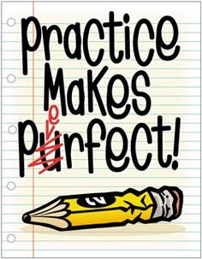](https://www.google.co.uk/url?sa=i&url=http%3A%2F%2Fclipart-library.com%2Fpractice-cliparts.html&psig=AOvVaw0MnjowcShRibrmGSEENlEU&ust=1587811401116000&source=images&cd=vfe&ved=0CAIQjRxqFwoTCNDTrcvwgOkCFQAAAAAdAAAAABAD)

|  |  |
| --- | --- |
| **Spelling Strategy** | **Example** |
| Phoneme Knowledge (PK) | Mon**ey** – the **‘ey’** phoneme in this word can help you to spell it. |
| Spelling Rule (SR) | M**a**k**e** – the ‘**silent e’** (or as we say ‘magic e’) makes the vowel ‘a’ say its name. |
| Word Within a Word (WWW) | Sp**ace** – the word ‘**ace’** helps us to spell the word ‘space’. |
| Mnemonic (M) | Rhythm – **R**hythm **H**elps **Y**our **T**wo **H**ips **M**ove. Creating a rhyme or poem can help you spell tricky words! |
| Syllabification (S) | Yesterday – **yes**/**ter**/**day**. This is when we clap out the syllables in the word.  ***Tip: Use our classroom strategy where we put our hand under our chin. Every time your chin moves, it’s a new syllable!*** |
| Compound Word (CW) | Football – **foot**/**ball.** Compound words are two or more words combined to make a new word like ‘football’. Try not to get this mixed up with ‘Word Within a Word’. |

**Reading Tasks**

|  |  |  |  |
| --- | --- | --- | --- |
| **Red Group** | **Blue Group** | **Green Group** | **Orange Group** |
| ***LI: To make informed predictions.***  **TASK**  Complete the ‘before reading’ columns in the Prior Knowledge worksheet. Read chapters 9 and 10 of ‘**Storm Chasers’** (Oxford Owl – link below). Complete the ‘after reading’ column.  **Oxford Owl Login**  **Username**:sthelensp6  **Password:** school  **Success Criteria:**  [Image result for star emoji](https://www.google.co.uk/url?sa=i&url=https%3A%2F%2Fwww.iemoji.com%2Fview%2Femoji%2F45%2Fanimals-nature%2Fglowing-star&psig=AOvVaw06GYxWwJ3AvNliwBAuGC65&ust=1585218982355000&source=images&cd=vfe&ved=0CAIQjRxqFwoTCLDI0YS3tegCFQAAAAAdAAAAABAD) *Identify the main ideas of the chapters.*  [Image result for star emoji](https://www.google.co.uk/url?sa=i&url=https%3A%2F%2Fwww.iemoji.com%2Fview%2Femoji%2F45%2Fanimals-nature%2Fglowing-star&psig=AOvVaw06GYxWwJ3AvNliwBAuGC65&ust=1585218982355000&source=images&cd=vfe&ved=0CAIQjRxqFwoTCLDI0YS3tegCFQAAAAAdAAAAABAD)*Summarise key points.* | ***LI: To make informed predictions.***  **TASK**  Complete the ‘before reading’ columns in the Prior Knowledge worksheet. Read chapters 9 and 10 of **‘Black Beauty’**  (Oxford Owl – link below). Complete the ‘after reading’ column.  **Oxford Owl Login**  **Username**:sthelensp6  **Password:** school  **Success Criteria:**  [Image result for star emoji](https://www.google.co.uk/url?sa=i&url=https%3A%2F%2Fwww.iemoji.com%2Fview%2Femoji%2F45%2Fanimals-nature%2Fglowing-star&psig=AOvVaw06GYxWwJ3AvNliwBAuGC65&ust=1585218982355000&source=images&cd=vfe&ved=0CAIQjRxqFwoTCLDI0YS3tegCFQAAAAAdAAAAABAD) *Use descriptive language to describe a given character.*  [Image result for star emoji](https://www.google.co.uk/url?sa=i&url=https%3A%2F%2Fwww.iemoji.com%2Fview%2Femoji%2F45%2Fanimals-nature%2Fglowing-star&psig=AOvVaw06GYxWwJ3AvNliwBAuGC65&ust=1585218982355000&source=images&cd=vfe&ved=0CAIQjRxqFwoTCLDI0YS3tegCFQAAAAAdAAAAABAD) *Use evidence from the text.* | ***LI: To create a book review.***  **TASK**  Listen to chapters 24 of ‘**Kid Normal’** story (audio version – link below). Complete the ‘Book Review’ activity.  **Success Criteria:**  [Image result for star emoji](https://www.google.co.uk/url?sa=i&url=https%3A%2F%2Fwww.iemoji.com%2Fview%2Femoji%2F45%2Fanimals-nature%2Fglowing-star&psig=AOvVaw06GYxWwJ3AvNliwBAuGC65&ust=1585218982355000&source=images&cd=vfe&ved=0CAIQjRxqFwoTCLDI0YS3tegCFQAAAAAdAAAAABAD) *Highlight your opinion of the book.*  [Image result for star emoji](https://www.google.co.uk/url?sa=i&url=https%3A%2F%2Fwww.iemoji.com%2Fview%2Femoji%2F45%2Fanimals-nature%2Fglowing-star&psig=AOvVaw06GYxWwJ3AvNliwBAuGC65&ust=1585218982355000&source=images&cd=vfe&ved=0CAIQjRxqFwoTCLDI0YS3tegCFQAAAAAdAAAAABAD)*Write in full sentences.* | ***LI: To use evidence from the text.***  **TASK**  Again, access **‘Things That Sting’**(Oxford Owl – link below). Read pages 16-23. Refer to the text and list the things you would need to do if you were to get a sting (pg 22-23).  **Oxford Owl Login**  **Username**:sthelensp6  **Password:** school  **Success Criteria:**  *[Image result for star emoji](https://www.google.co.uk/url?sa=i&url=https%3A%2F%2Fwww.iemoji.com%2Fview%2Femoji%2F45%2Fanimals-nature%2Fglowing-star&psig=AOvVaw06GYxWwJ3AvNliwBAuGC65&ust=1585218982355000&source=images&cd=vfe&ved=0CAIQjRxqFwoTCLDI0YS3tegCFQAAAAAdAAAAABAD)Create list of clear instructions.* |

**Link to Clips:**

**Red Group** <https://www.oxfordowl.co.uk/api/digital_books/1386.html>

**Blue Group** <https://www.oxfordowl.co.uk/api/digital_books/1336.html>

**Green Group** <https://stories.audible.com/pdp/B07533YSBN?ref=adbl_ent_anon_ds_pdp_pc_cntr-1-1>

**Orange Group** [**https://www.oxfordowl.co.uk/api/interactives/12942.html**](https://www.oxfordowl.co.uk/api/interactives/12942.html)

**Numeracy Tasks**

**1) Mental Starter:** Play 1 round of ‘Hit the Button’ and select the times tables option (this should only take around 5 minutes). <https://www.topmarks.co.uk/maths-games/hit-the-button>

**2) Number Talks:** Try to aim to solve your chosen question within 5 minutes (use a timer). If you manage to solve the problem with time to spare, try to use a different Number Talks strategy like we do in class. See the grid below to recap your strategies.

|  |  |
| --- | --- |
| **[Chilli Challenge Clipart](https://www.google.co.uk/url?sa=i&url=https%3A%2F%2Fwww.clipart.email%2Fclipart%2Fchilli-challenge-clipart-491405.html&psig=AOvVaw1ctoQm2_UE24lhA4pyCN2a&ust=1589375662782000&source=images&cd=vfe&ved=0CAIQjRxqFwoTCMCd3fWzrukCFQAAAAAdAAAAABAD)Hot** | 1188 ÷ 12 = |
| **[Chilli Challenge Clipart](https://www.google.co.uk/url?sa=i&url=https%3A%2F%2Fwww.clipart.email%2Fclipart%2Fchilli-challenge-clipart-491405.html&psig=AOvVaw1ctoQm2_UE24lhA4pyCN2a&ust=1589375662782000&source=images&cd=vfe&ved=0CAIQjRxqFwoTCMCd3fWzrukCFQAAAAAdAAAAABAI)Spicy** | 98 ÷ 14 = |
| **[Green Chilli Clipart](https://www.google.co.uk/url?sa=i&url=https%3A%2F%2Fwww.clipart.email%2Fclipart%2Fgreen-chilli-clipart-441259.html&psig=AOvVaw1ctoQm2_UE24lhA4pyCN2a&ust=1589375662782000&source=images&cd=vfe&ved=0CAIQjRxqFwoTCMCd3fWzrukCFQAAAAAdAAAAABAU)Mild** | 72 ÷ 8 = |

Number Talks Strategy Examples – Division

You may recognise some of these sums from our Maths wall. I have created this grid to recap your memory of the different division strategies we have learned in class.

|  |  |  |
| --- | --- | --- |
| **Repeated Subtraction**  25 ÷ 5 = 5  25  -5  20  When you reach 0, count up how many **5’s** you have used to complete the sum.  -5  15  -5  10  -5  5  -5  0 | **Sharing/Dealing Out**  25 ÷ 5 = 5 | **Multiplying Up**  308 ÷ 14 = 22  10 x 14 = 140  10 x 14 = 140  2 x 14 = 28  140 + 140 + 28 = 308. When you reach the starting point in the sum, the last step is to add your circles (ie 10 + 10 + 2). |
| **Partial Quotients**  308 ÷ 14 = 22    14 308  -140 10  168  -140 10  28  -28 2  0 | **Proportional Reasoning**  308 ÷ 14  ÷ 7  ÷ 7  44 ÷ 2 = 22  Find a common multiple in each of the numbers. Remember, if it is an even number, try dividing by 2 if you are struggling. This is a good first step. | **Final Number Talks Hints**   * Choose the strategy you feel most confident in to begin with. * Afterwards, you can begin to think about the strategy that is **most efficient** for your given sum. *(This is a top goal of ours in class).* * Show your working. |

|  |  |  |  |
| --- | --- | --- | --- |
| **Red Group** | **Blue Group** | **Green Group** | **Orange Group** |
| ***LI: To estimate the size of given angles.***  **TASK**  Complete the red angles worksheet. Estimate the size of each angle. *You can refer to Thursday’s task to help you.*  ***Note: As these are estimations, you do not need a protractor.***  **Success Criteria:**  [Image result for star emoji](https://www.google.co.uk/url?sa=i&url=https%3A%2F%2Fwww.iemoji.com%2Fview%2Femoji%2F45%2Fanimals-nature%2Fglowing-star&psig=AOvVaw06GYxWwJ3AvNliwBAuGC65&ust=1585218982355000&source=images&cd=vfe&ved=0CAIQjRxqFwoTCLDI0YS3tegCFQAAAAAdAAAAABAD)*Use knowledge of angles to create accurate estimations.* | ***LI: To recognise and identify acute, right and obtuse angles.***  **TASK**  Complete the blue angles worksheet. Estimate the type of angle below. Use the colour key provided.  **Success Criteria:**  [Image result for star emoji](https://www.google.co.uk/url?sa=i&url=https%3A%2F%2Fwww.iemoji.com%2Fview%2Femoji%2F45%2Fanimals-nature%2Fglowing-star&psig=AOvVaw06GYxWwJ3AvNliwBAuGC65&ust=1585218982355000&source=images&cd=vfe&ved=0CAIQjRxqFwoTCLDI0YS3tegCFQAAAAAdAAAAABAD)*Estimate the type of angle given.*  *[Image result for star emoji](https://www.google.co.uk/url?sa=i&url=https%3A%2F%2Fwww.iemoji.com%2Fview%2Femoji%2F45%2Fanimals-nature%2Fglowing-star&psig=AOvVaw06GYxWwJ3AvNliwBAuGC65&ust=1585218982355000&source=images&cd=vfe&ved=0CAIQjRxqFwoTCLDI0YS3tegCFQAAAAAdAAAAABAD)Use an appropriate colour key.* | ***LI: To identify lines of symmetry.***  **TASK**  Complete the ‘green’ symmetry task. Identify shapes/patterns that are symmetrical.  **Success Criteria:**  [Image result for star emoji](https://www.google.co.uk/url?sa=i&url=https%3A%2F%2Fwww.iemoji.com%2Fview%2Femoji%2F45%2Fanimals-nature%2Fglowing-star&psig=AOvVaw06GYxWwJ3AvNliwBAuGC65&ust=1585218982355000&source=images&cd=vfe&ved=0CAIQjRxqFwoTCLDI0YS3tegCFQAAAAAdAAAAABAD)*Draw horizontal and/or vertical lines on shapes to create lines of symmetry.* | ***LI: To create a symmetry information poster.***  **TASK**  Create a poster which highlights what lines of symmetry are. Present this to an adult/family member.  **Success Criteria:**  [Image result for star emoji](https://www.google.co.uk/url?sa=i&url=https%3A%2F%2Fwww.iemoji.com%2Fview%2Femoji%2F45%2Fanimals-nature%2Fglowing-star&psig=AOvVaw06GYxWwJ3AvNliwBAuGC65&ust=1585218982355000&source=images&cd=vfe&ved=0CAIQjRxqFwoTCLDI0YS3tegCFQAAAAAdAAAAABAD)*Identify definition of symmetrical lines.*  *[Image result for star emoji](https://www.google.co.uk/url?sa=i&url=https%3A%2F%2Fwww.iemoji.com%2Fview%2Femoji%2F45%2Fanimals-nature%2Fglowing-star&psig=AOvVaw06GYxWwJ3AvNliwBAuGC65&ust=1585218982355000&source=images&cd=vfe&ved=0CAIQjRxqFwoTCLDI0YS3tegCFQAAAAAdAAAAABAD)Give an example of a symmetrical shape.* |

**3) Main Tasks:**

**Red and Blue Clips:** [**https://www.bbc.co.uk/teach/skillswise/angles/zbxqrj6**](https://www.bbc.co.uk/teach/skillswise/angles/zbxqrj6)

**Green and Orange Clips:** [**https://www.youtube.com/watch?v=_Xs56r9o3Tw**](https://www.youtube.com/watch?v=_Xs56r9o3Tw)

R.E Task

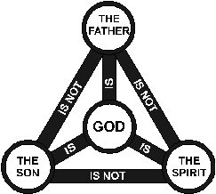LI: *To explore the three strands of the Holy Trinity.*

This image represents God as the Father, the Son and the Holy Spirit.

[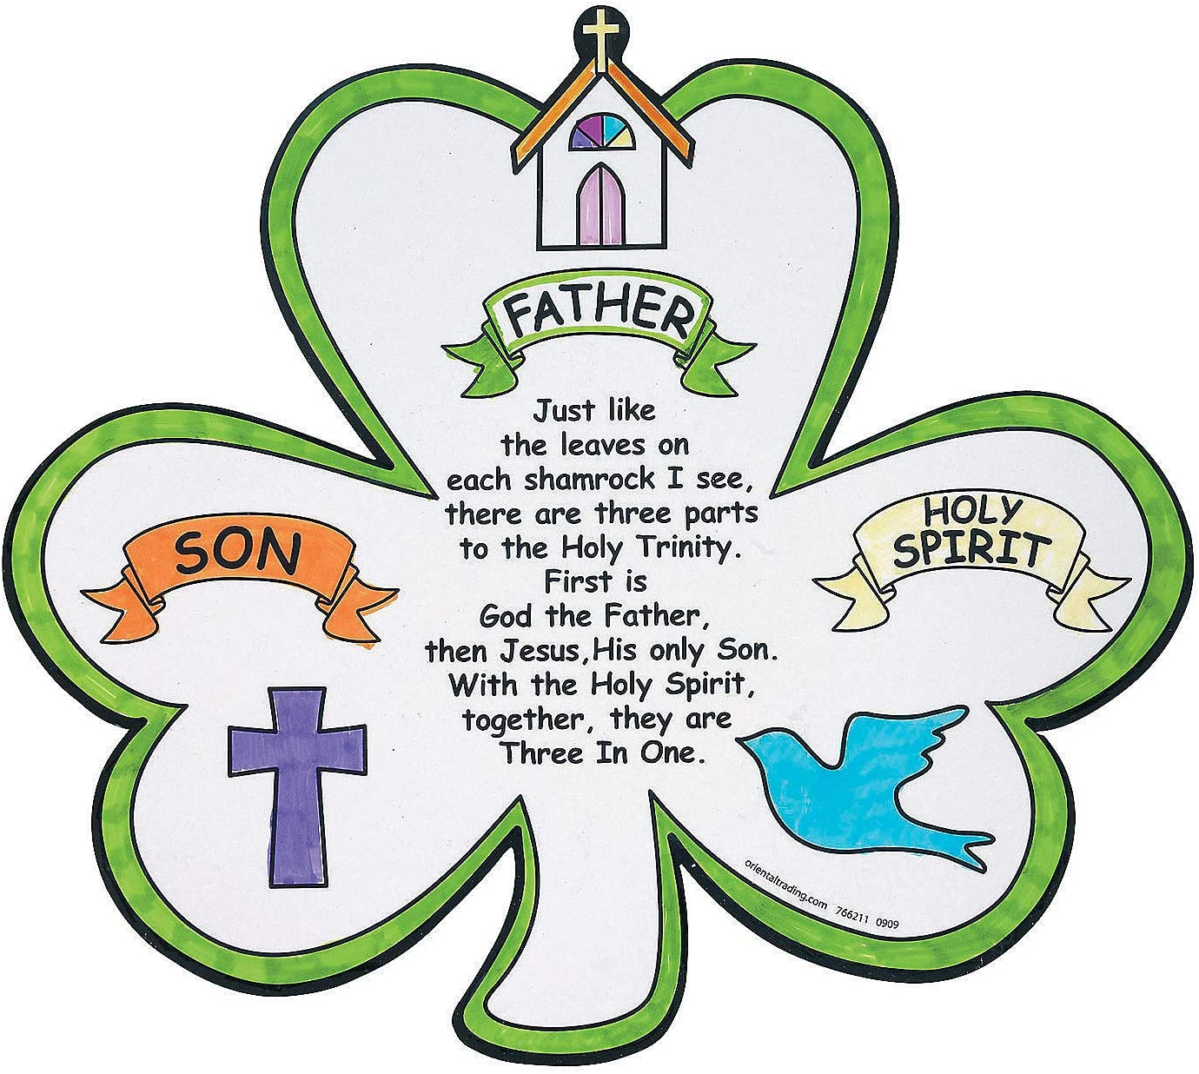](https://www.google.co.uk/url?sa=i&url=https%3A%2F%2Fwww.amazon.co.uk%2FShamrock-Patricks-Trinity-Cutouts-Sunday%2Fdp%2FB006VXZDT8&psig=AOvVaw2mF6Q1Gkcrcs_U6YqouEFV&ust=1591103796383000&source=images&cd=vfe&ved=0CAIQjRxqFwoTCMCs79fZ4OkCFQAAAAAdAAAAABAJ)

You may remember our class discussion about this during St Patrick’s Day. ***Remember: St Patrick used a shamrock to explain this.*** It is important to remember that God is central to all three strands.

Task: Your task is to create your own Holy Trinity craft. Be as creative as possible. Here are some examples below:

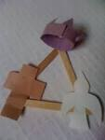

Please find the literacy worksheets for today’s tasks below.

**Green – Spelling 1**

**Magic ‘e’ Task**

LI: To identify silent ‘e’ words.

[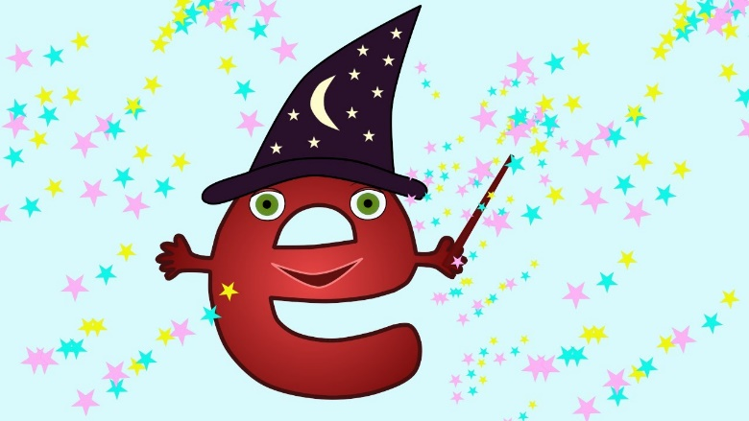](https://www.google.co.uk/url?sa=i&url=https%3A%2F%2Fwww.youtube.com%2Fwatch%3Fv%3DbZhl6YcrxZQ&psig=AOvVaw185TMNCfRrxcjGZEIiXmvt&ust=1591095451170000&source=images&cd=vfe&ved=0CAIQjRxqFwoTCLDy0sy64OkCFQAAAAAdAAAAABAD)

The ‘**silent e’** (or as we often say ‘magic e’) makes the vowel say its name.

Access the catchy magic ‘e’ song here - <https://www.youtube.com/watch?v=bZhl6YcrxZQ>

Task 1:

Create 5 sentences using your 5 spelling words.

bake

cake

lake

time

lime

**Green – Spelling 2**

Task 2: ‘Roll and Read’

This task is similar to the ‘roll and read’ boards that we use in class. Roll a dice and move your counter along the given number of stars. Read the word that you land on out loud. You may wish to read this to siblings or an adult.

NOTE:

If you do not have a dice, you can use a virtual dice here at: <https://www.random.org/dice/?num=1>

If you do not have a counter you could use a coin or a piece of card.

[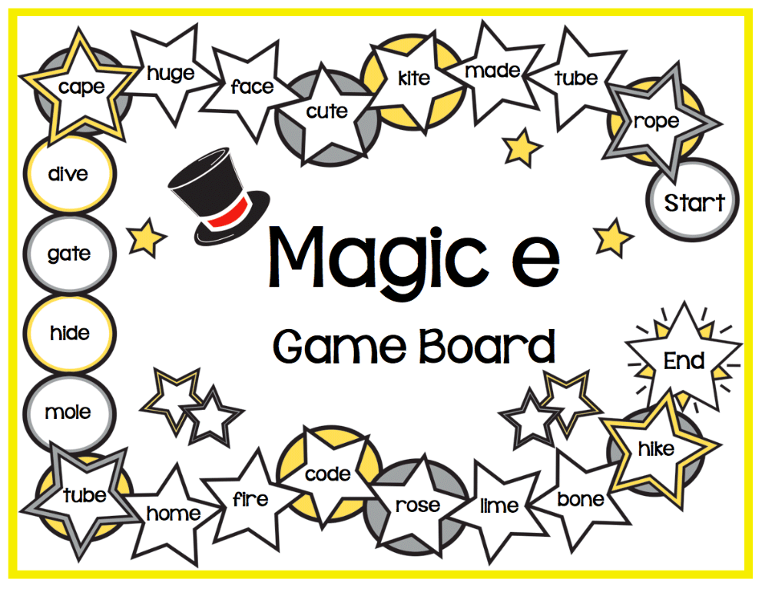](https://www.google.co.uk/url?sa=i&url=https%3A%2F%2Fblog.maketaketeach.com%2Factivities-for-teaching-the-magic-e-rule%2F&psig=AOvVaw185TMNCfRrxcjGZEIiXmvt&ust=1591095451170000&source=images&cd=vfe&ved=0CAIQjRxqFwoTCLDy0sy64OkCFQAAAAAdAAAAABAN)

***Red and Blue Reading Tasks***

**Prior Knowledge**

LI: *To use my prior knowledge of the events so far to help me predict what may happen in the next chapter.*

Before reading chapter 4, complete the ‘before reading’ columns in the table below. After you have read chapter 4 with your partner, explore how your thinking has changed. Remember to include evidence from the text.

|  |  |  |
| --- | --- | --- |
| **Before reading** | **Before Reading** | **After Reading** |
| What I think will happen in this chapter | What my partner thinks will happen | How my thinking has changed |

*Green Reading Task*

[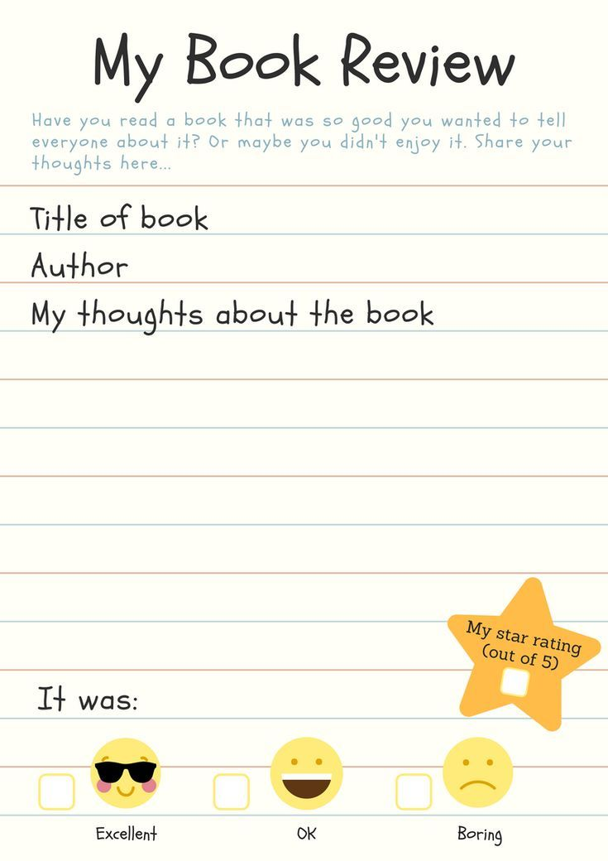](https://www.google.co.uk/url?sa=i&url=https%3A%2F%2Fwww.pinterest.co.uk%2Fpin%2F127226758208371826%2F&psig=AOvVaw07HWDOtyN5mbUuJXkIKxWL&ust=1591096411387000&source=images&cd=vfe&ved=0CAIQjRxqFwoTCPCBwJS-4OkCFQAAAAAdAAAAABAI)

***Red Group Maths Task***

[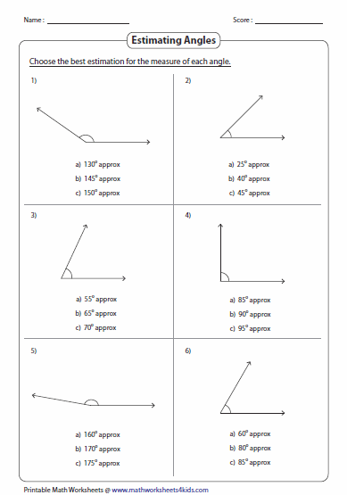](https://www.google.co.uk/url?sa=i&url=https%3A%2F%2Fwww.pinterest.com%2Fpin%2F154318724707875656%2F&psig=AOvVaw1WseAKbsZW_iarguTHQY-S&ust=1591098681054000&source=images&cd=vfe&ved=0CAIQjRxqFwoTCPCn3s_G4OkCFQAAAAAdAAAAABAQ)