What would these animals sit on?
There are clues at the bottom of the page. Remember it has to rhyme

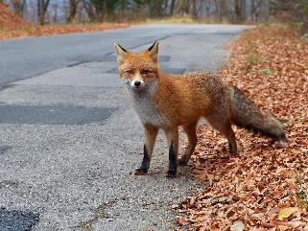 foxes sit on b_ _ _ _
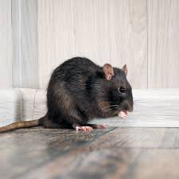 rats sit on h_ _ _
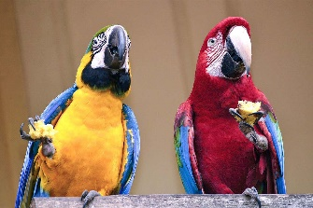 parrots sit on c_ _ _ _ _ _
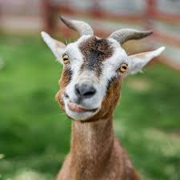 goats sit on c_ _ _ _
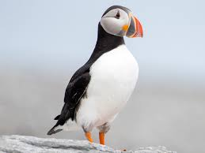 puffins sit on m_ _ _ _ _ _
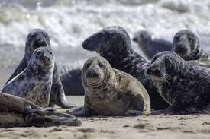 seals sit on w_ _ _ _ _

muffins boxes coats
wheels carrots hats

