Proper Noun Hunt
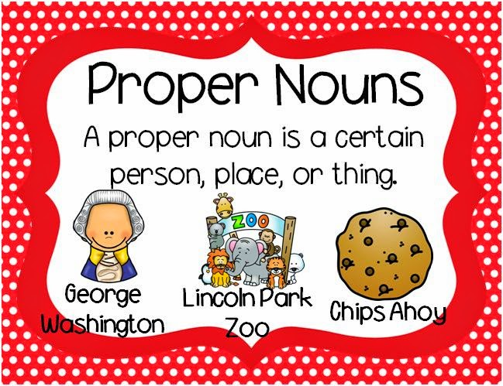
Remember a proper nouns names a specific place, object or person.

Can you spot the missing capital letters for the proper nouns in Mr Whoop’s letter?

12 green lane,
whoopsville,
TX 76123
Dear mr. williams,
I am writing to you to complain about my recent visit to your supermarket, costsavers, on thursday, january 12, 2017. After a recent vacation in europe (where I visited portugal, spain and italy), I came to your store to purchase some ingredients to make a mediterranean meal like the one I had eaten near the colosseum.
While in your fruit and vegetable aisle, I accidentally tripped over a red onion and two of your shop assistants, whose name badges read daniel and julie, proceeded to laugh at me hysterically. They never offered me any help or assistance. I was appalled.
I raced outside, got into my car and went straight home empty-handed. I had to call my local branch of palace pizzas to order takeout. I will not be coming back in your shop until I get a full apology. If I don’t receive a letter by wednesday march 1st, I am even considering writing to the whoopsville government or the president to express my disgust.
Yours sincerely,
mr. whoops

